An Automated Winch System for Underwater Sampling

MSU ECE Smart MicroSystems Lab

Final Report - Team 12

ECE 480

6 December 2019

Nick Alfano, Adam Chapman, Paul Hanvey, Yacer Mirza,

Parwesh Rallapalli, Philip Schmitz, Funakoshi Silva

Facilitator: Dr. Sunil Chakrapani

Sponsor: Dr. Xiaobo Tan

**EXECUTIVE SUMMARY:**

This report lays out the completed work for the Automated Winch System for Underwater Sampling Project, as directed by the MSU Smart MicroSystems Lab. The objective of this project was to develop a winch system that can lower a system to any desired depth underwater based on a user-input value and the feedback it receives from a pressure sensor. The work itself was split into four main components: power distribution, communication, controls, and component management. Energized by two 18.5V batteries in parallel, the system must distribute the power to a 12V winch, a 5-7V PixHawk controller, and a 5V Raspberry Pi. The communication aspect of the work included the constant interface between the pressure sensor and the Raspberry Pi, so that the winch could decide to alter its depth. The PixHawk’s primary role was to control the boat to certain coordinates, similar to how a drone operates. Furthermore, the PixHawk had to ensure that both the boat thrusters and winch would not be on at the same time so as to not overdraw power from the battery. Finally, the design must be constricted so that all components can fit inside a waterproof case. A solid blend of electrical, computer, and mechanical operations, the project eventually proved successful. At the conclusion of the semester, the team was able to efficiently enter a certain depth and have the winch automatically lower or raise the system to that point. All parts, additionally, were compartmentalized into the waterproof casing, making the project a success. This progress will set the foundation for future work within the Smart Microsystems Lab.

**Acknowledgments**

Our team would like to give our utmost appreciation to our project sponsor Dr. Tan for his support of our team. We’d also like to acknowledge Chandler Panetta for his tremendous contribution to the guidance and success of our team. He made sure we were on track with our ideas and gave us to the proper resources to lead our team to success. Many thanks to Dr. Chakrapani who also kept us on track to our goals throughout the semester. Lastly, we’d like to thank Danton Thon whose expertise was greatly beneficial to us. He was able to fix an issue we unexpectedly encountered on short notice which led us smoothly to the final project we have today.

Table of Contents

**Chapter 1**

Introduction ………………………………………………………………………...4

Background ………………………………………………………………………...4

Objectives …………………………………………………………………………..6

Design Specifications ……………………………………………………………....6

**Chapter 2**

Selecting an Approach……………………………………………………………...9

Budget ……………………………………………………………………………...9

Activity Timeline …………………………………………………………………10

**Chapter 3**

Power Distribution Board Design…………………………………………………..12

Winch Hardware Design and Implementation……………………………………...14

Winch Software and Interface Design Requirements ……………………………...17

Implementation of Wireless Communication………………………………………17

State Machine Design and Implementation ……………………………………......18

Graphical User Interface (GUI) Design ………………………………..…………..19

Graphical User Interface (GUI) Implementation ………………………...………...20

Sensor to Raspberry Pi Interfacing …………………………………………….….. 21

Pixhawk Design Efforts and Implementation……………………………………….21

Dronekit Simulation ………………………………………………………………. 23

**Chapter 4**

Test Data………………………………………………………………………….….26

**Chapter 5**

Final Cost ……………………………………………………………………………29

Success and Failures ………………………………………………………………...30

Suggestions for Future Work ………………………………………………………..30

**Appendix 1**  
 Technical roles, Responsibilities, and Work Accomplished…………………………32

**Appendix 2** Literature and Website References…………………………………………………...39

**Appendix 3**

Detailed Technical Attachments……………………………………………………...40

**CHAPTER 1**

**INTRODUCTION:**

The MSU Smart MicroSystems Lab (SML), along with Dr. Xiaobo Tan, Dr. Chakrapani, and Chandler Panetta, has commissioned the Automated Winch System for Underwater Sampling project.

In this project, the team will design and develop a compact, automated winch system that can lower environmental sensors down to any desired depth based on the feedback from a pressure sensor. After thoroughly interviewing the customers, the team proposed a design that will be divided into four main modules: power distribution, communication, controls, and data cables. Each of these modules has its unique set of requirements, as voiced by the customer to ensure the design will fit future work of the SML. The main focus of the power distribution module will be to divide the 18.5V battery, such that it is distributed as four voltages to the thruster, winch, Raspberry Pi, and the PixHawk controller. The communication aspect of the project is twofold. First, the pressure sensor must be able to be commanded by the Raspberry Pi to achieve a certain depth. Next, the sensor must wirelessly transmit its exact depth in real time back to the Pi. The controller module will include use of the PixHawk to command the depth of the winch system itself. It will be in constant contact with the Raspberry Pi to monitor water depth. Additionally, there will be a failsafe mechanism on the device that will not allow both the winch and thruster to be on at the same time. Finally, the data cable portion of the project will include the application of physically increasing or decreasing the line in the winch. This module must optimize the strength of the cable, while reducing water ingress and data loss over the required distance.

Previously, autonomous surface craft (ASC) have been limited to the water surface. This project, however, when integrated with an ASC, will enable robotic sampling of three-dimensional underwater environments. The work here will expand on a recent goal of the Smart MicroSystems Lab, which is to develop a more integrated method of using mobile robots to automate fish tracking. By laying the foundation with this automated winch system, SMLwill be able to bring this objective to fruition.

A diverse mix of seven engineers, the team consists of four EE’s and three CpE’s. The power distribution and controller modules will be headed primarily by the team’s electrical engineers. The communication and data cable modules offer a mix of software and hardware engineering that will be headed by the group’s computer engineers.

**BACKGROUND:**

The team is working with Dr. Xiaobo Tan and the Michigan State University Electrical and Computer Engineering Smart Microsystems Laboratory (SML) to create the Automated Winch System for Underwater Sampling. SML, led by Dr. Tan, has a mission to enable smarter, smaller, integrated systems by merging advanced modeling, control and design methodologies with novel materials and fabrication processes. Research at SML focuses on electroactive polymer sensors and actuators, modeling and control of smart materials, soft robotics, bio-inspired underwater robots, and underwater mobile sensing. [1]

Many of the previous projects the Smart Microsystems Laboratory focus on robotic fish. Robotic fish are underwater robots that emulate locomotion of live fish through actuated fin and/or body movements. They are of increasing interest due to their potential applications such as aquatic environmental monitoring and robot-animal interactions. [2]One application of the research and development of robotic fish is automated fish tracking. SML has begun developing other ways to use mobile robots for automated fish tracking as well, such as using Autonomous Surface Craft.

Project lead and master’s student Chandler Panetta has been researching Time Difference of Arrival-based localization using Autonomous Surface Craft to automatically track the location of certain fish. The United States Geological Survey (USGS) implants certain fish with an acoustic tag, and underwater acoustic receivers will detect the pings from the tag. There are four receivers, which then record the time of arrival for each ping. Each receiver is at a known location and depth, and using the time of arrival at each receiver, the exact location of the fish can be determined at the time the tag sent the ping.

The current method for staging said receivers is outdated, and the team will be developing a new Automated Winch System for Underwater Sampling to assist in the research for automated fish tracking. Previous teams have created a power distribution system for the Autonomous Surface Craft. The system consisted of a 18.5V LiPo battery connected to a six-position terminal block, a PixHawk powered by a PixHawk power module, a thruster connected to an 18.5V rail using BlueRobotics electronic speed controller, and a 5V ServoRail powered by a simple buck converter. This design is illustrated in **Figure 1.** The current team will need to optimize this design with a power distribution board so that an electronic anchor (winch) can be added without increasing the size of the power supply.

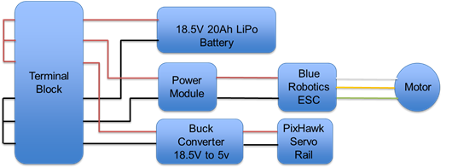

**Figure 1: Previous design of power distribution system**

**OBJECTIVES:**

The team has been given four base objectives, each is fairly complex and comes with its own list of more specific requirements. They will require time and understanding to complete them, however, the base objectives are straightforward. For the first objective, the team is tasked with designing a power distribution board that can supply power to every component on the craft. This includes powering the BlueRobotics Electronic Speed Controller and its associated BlueRobotics Thruster, the PixHawk, the Raspberry Pi and the Trac Deckhand 40 Winch. These components have varying power requirements meaning that the team will need to use circuitry that can distribute and manage power to each device correctly.

The second objective the team is faced with is communication between all devices. There are several lines of communication that need to be established based upon the requirements from the sponsor. Communication between the host computer and the PixHawk Controller, between the PixHawk and the Raspberry Pi, between the Raspberry Pi and the winch, the depth sensor, and the underwater technology that the Smart Microsystems Lab will eventually implement. This objective will be mostly handled on the programming side, however, it has a few electrical needs that must be addressed.

Moving on to the third objective, the controller. This is the link between the communication and the power. The controller will control things like the coordinates of the watercraft’s destination and the routing of power to operate the crafts thruster or winch. The controller will be responsible for a very important portion of the project and that is component and circuit protection. Due to the restrictions that come with using batteries, the team cannot exceed the maximum current capabilities of the battery without having unstable and potentially fatal implications. The controller will be responsible for operating a relay that will route current to one of the two very demanding components on the boat.

Finally, the fourth objective is a more simple objective. The team is asked to replace the rope that comes standard on the Trac Deckhand 40 Winch with a data cable that is capable of meeting the communication requirements as well as being strong enough to support its own weight as well as the sensors weight.

**DESIGN SPECIFICATIONS:**

Each of these four objectives, as mentioned above, has some very important design specifications that must be considered in order to successfully complete the project. Some of the basic design specifications were covered above, this section will explain more about the basic specifications as well as touch on some of the smaller details. One of the most important aspects of this project is the power distribution board. The Smart Microsystems Lab has asked the team to design and fabricate a PCB that will satisfy all power distribution needs. Specifically, the PCB needs to be small enough to fit within the Pelican waterproof case that will eventually be provided. The dimensions have not been given, however, before any PCB design is considered the measurements will be provided. Another PDB spec that is pre-determined by the project sponsor is the input and output voltages of the system. The Smart Microsystems Lab has provided the team with two 18.5V batteries that will be run in parallel and each have a maximum current draw of 20A. The board will be responsible for powering a Raspberry Pi, which takes a 5V, 2.5A input. Since the batteries provide 18.5V the PDB will require a DC to DC conversion. This will be done by implementing a buck converter within the board. The buck converter uses a switching voltage regulator along with a series of electrolytic capacitors, ceramic capacitors, resistors, an inductor and a diode to regulate voltage as needed; in this case, 5V. The same principle will be used when converting 18.5V to 12V for the Trac Deckhand 40 Winch. The winch can take up to 20A. It becomes evident that there is a current draw issue if the winch is operating at full load as well as both thrusters working at full thrust. This will be addressed shortly. The board will also power two BlueRobotics Electronic Speed Controllers (ESCs) that will control two BlueRobotics Thrusters. The ESCs can take voltage anywhere between 7-26V and draws 32A at max. Again, noting that this would exceed the abilities of the batteries if ran in conjunction with the winch. There are two methods that will be implemented to combat this. First, the thrusters will have a software stop that does not allow them to run at max power. Second, the PDB will have a relay that is controlled by the Raspberry Pi. The relay will engage only the thrusters or the winch at one moment, never allowing both components the ability to simultaneously draw current from the battey.

While there are many design specifications for the PCB Power Distribution Board, there are not as many for the other 3 objectives: Communication, Controller and Data Cable. In terms of communication, The Smart Microsystems Lab asked the team to use X-Bee to communicate with the Raspberry Pi. The Raspberry Pi will also need to be fed GPS data from the PixHawk, therefore, sufficient communication between the two modules will be very important. For the controller, it will need to maintain the operation of the relay in order to preserve the battery as well as use GPS coordinates to route the watercraft to its destination. Finally, some thought has to go into choosing the right data cable to meet the specifications set. The cable must be tested for water ingress and be strong enough to, without a doubt, pull its own weight plus all sensors.

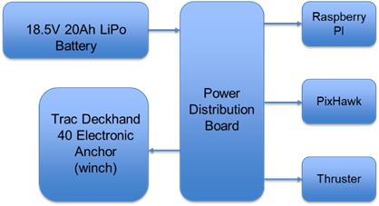

**Figure 2: Proposed Design of Power Distribution Components**

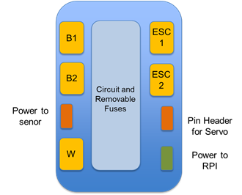

**Figure 3: Proposed Layout of Power Distribution Board**

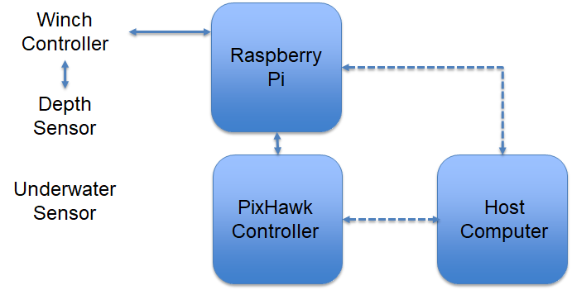

**Figure 4: Proposed State Machine Flowchart**

**CHAPTER 2**

**SELECTING AN APPROACH:**

The MSU Smart Microsystems Lab developed this project to aid in the collection of data in an ongoing project. Before handing the project off to the team, the SML first set their requirements. The lab required that we fit all of our electronics within a Pelican waterproof case and that the team used the winch that the SML had already purchased. This narrowed the teams possibilities in terms of coming up with a design. As a result, the team chose to pursue the approach outlined in our proposal. The team would design a power distribution board using buck converters to appropriately power every component, we would write software that would allow a user to input a location and a depth and execute those commands respectively and we would use a raspberry pi to control the winch. Each of these components is outlined in detail in the latter chapters. Over the duration of the project there were a number of small components that were overlooked in the planning stages of the project. These changes included things like, a 4 channel relay that would control the direction of the winch, a pulse width modulator to control the speed of the winch, a weight designed to pull the sensor as deep as possible and a GPS module reserved for the raspberry pi. All of these components were not anticipated but eventually their importance became apparent and the team responded accordingly.

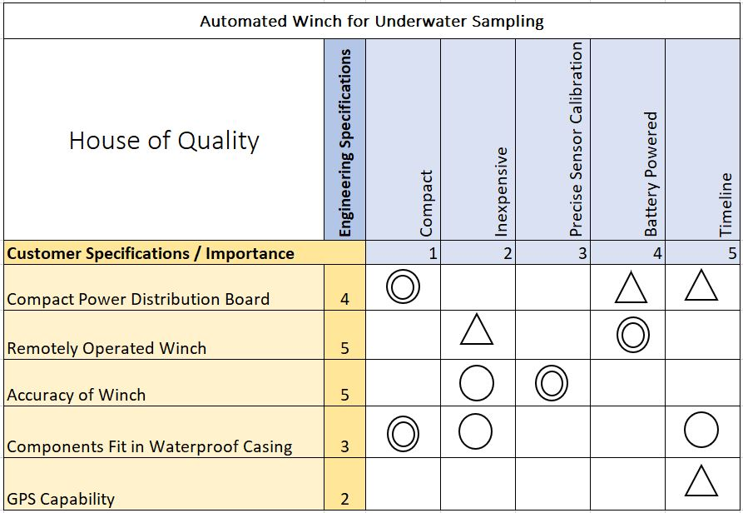

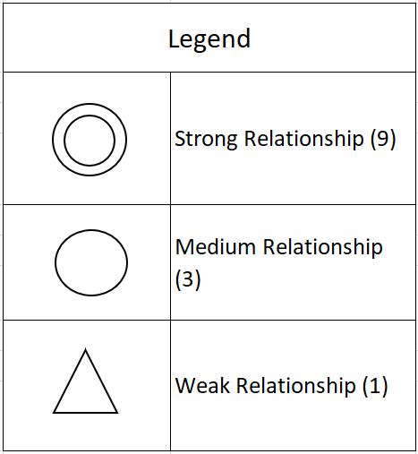

**Figure 5: The house of quality chart establishes the relationship between customer needs and design application.**

**BUDGET:**

The cost of a project is an important factor of its success. The initial budget created for our winch project was intended to be as conservative as possible to allow plenty of room for error. This cushion was critical to us because the team was dealing with the fabrication of custom printed circuit boards, expensive sensor units, and the use of delicate electronics in an aquatic setting. As shown in Figure 3, the team budgeted mostly for macro-sized components that would not be provided by the sponsor. While budgeting to the smallest component allows for a more accurate cost tracking system, it does not afford as much flexibility. When building a prototype it is often necessary to be flexible in order to make a product that still meets its end goal objectives. The initial cost of all the parts necessary to build the functioning automated winch came out to be $416.50. This estimate neglected shipping costs and any other fees that may occur. It was determined that staying under the $500 limit would be very feasible given the project mostly consisted of the integration of different subsystems.

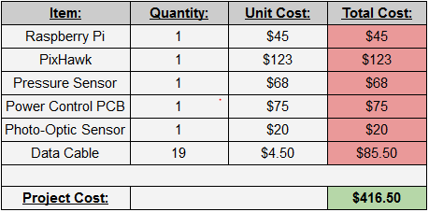

**Figure 6: Budget Table**

**ORIGINAL GANTT CHART**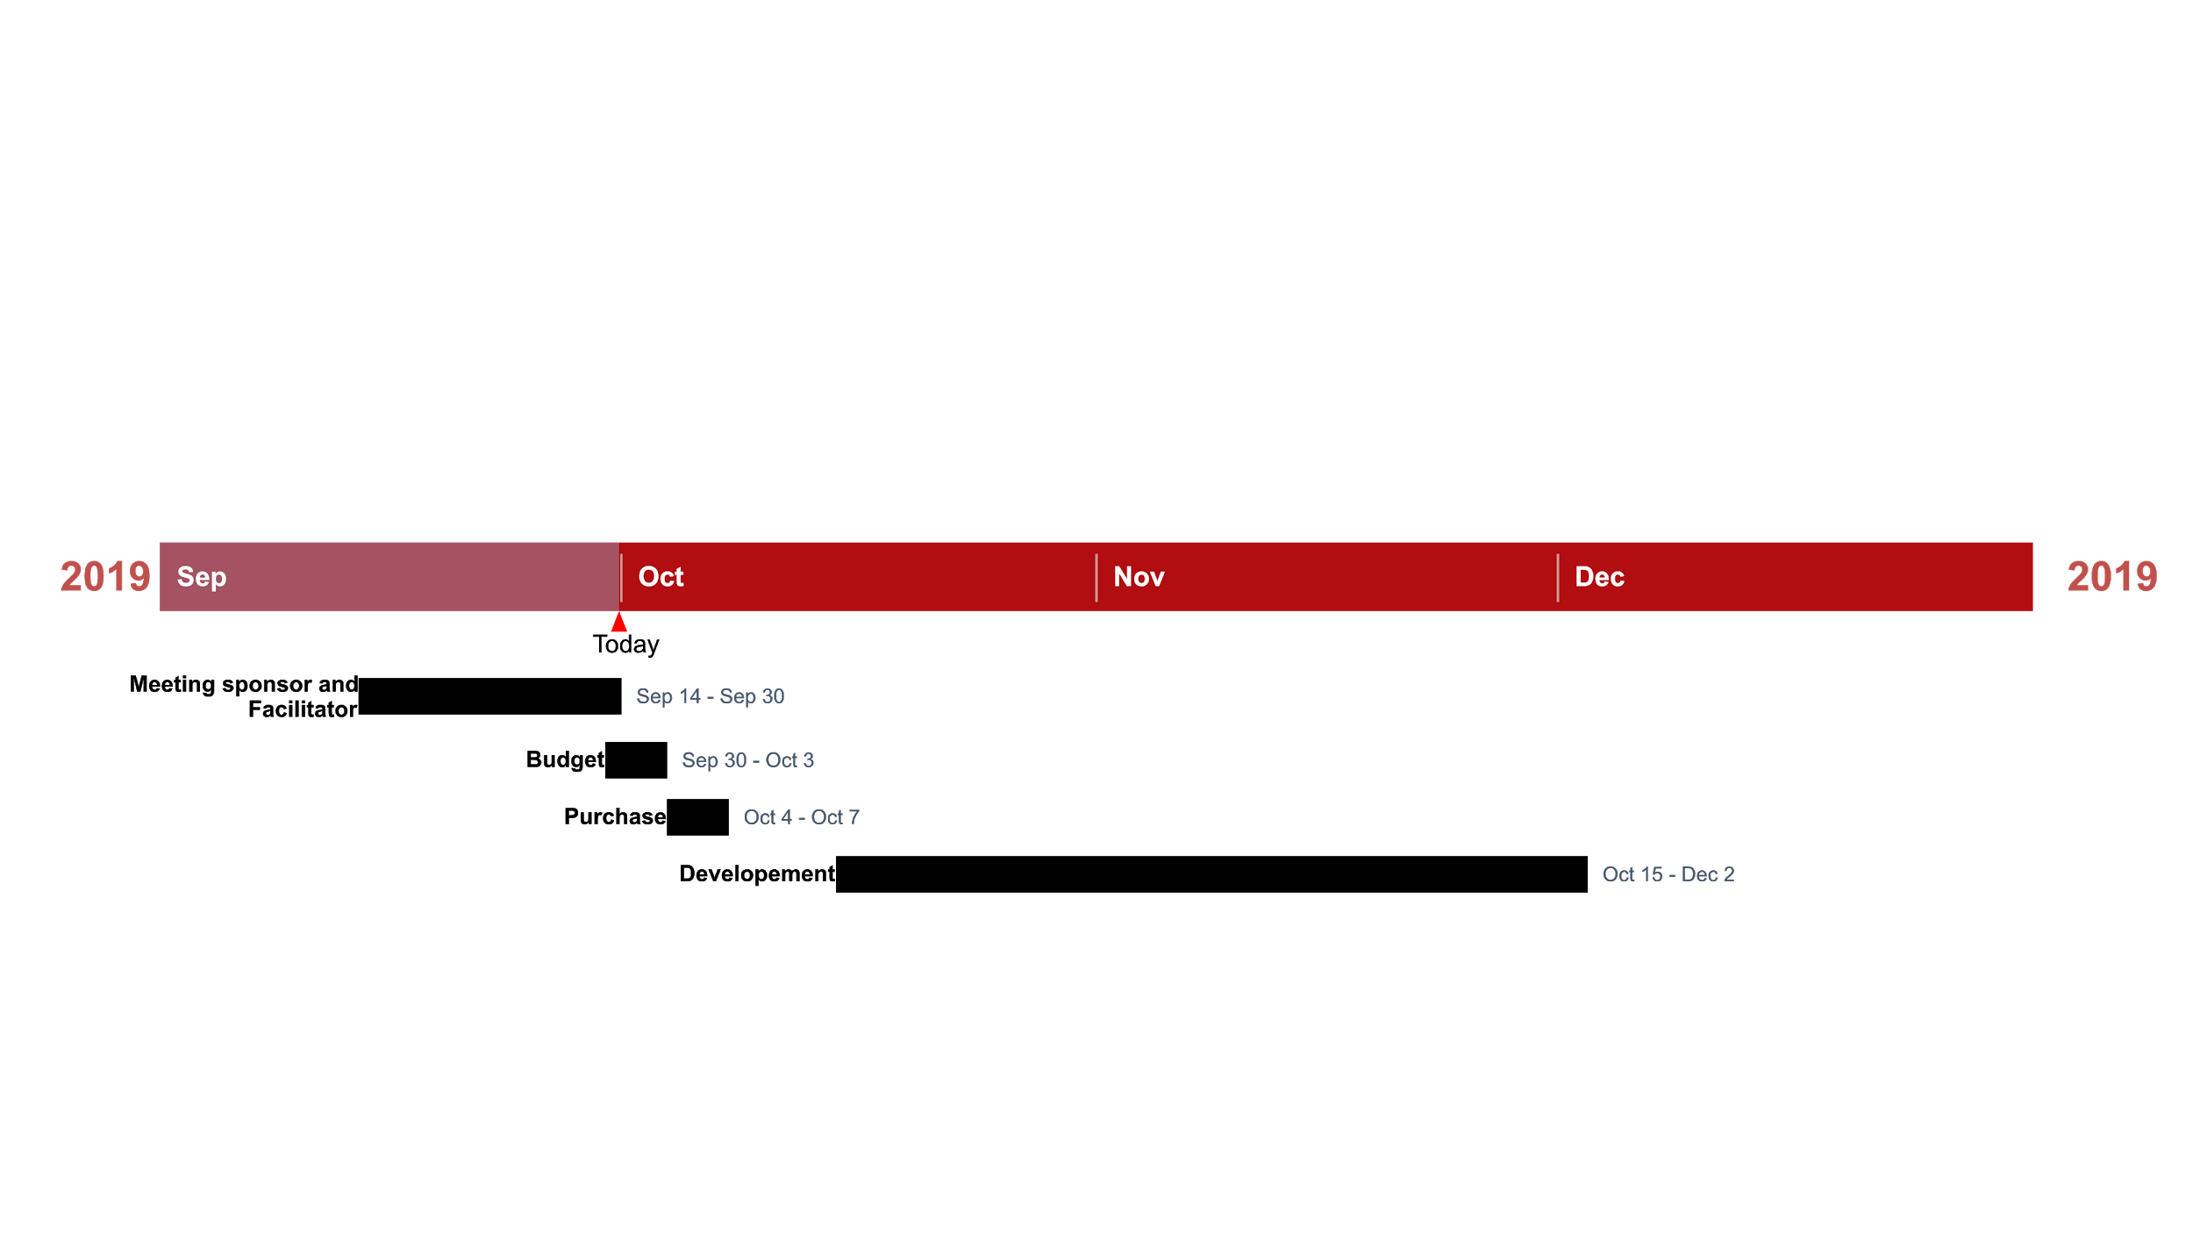

**Figure 7: Initial Gantt Chart**

**UPDATED GANTT CHART**

The Gantt chart can be found at the end of the report in **Appendix 3**. Below is listed the tasks scheduled for the completion of the automated winch project. The tasks were organized in a way that allowed the team to complete two of the most important milestones that refers to testing the winch prior to access to the water tank, and after access to the water tank. These two milestones were the most important because in order to complete the test without the tank most electrical components need to be installed and the software state machine needed to be completed in order to communicate to the electrical components via the raspberry pi microcontroller.The testing after access to the water tank is crucial because it allowed to notice software flaws, and electrical flaws therefore helping the team to iterate the worked done. Other reason why testing after access to the water was crucial because it allowed to gather data regarding the accuracy of the photo-optic sensor, being that crucial for the sensor calibration.Updates to the Gantt chart were made because as the project was evolving and the team started to get more knowledgeable regarding the project, new technical challenges started to be noticed, and new ideas started to be created. The new Gantt chart in comparison to the previous, presents a more detailed breakdown of the team tasks, and due dates, and a more detailed visual analysis of the completed tasks and milestones for the winch project.

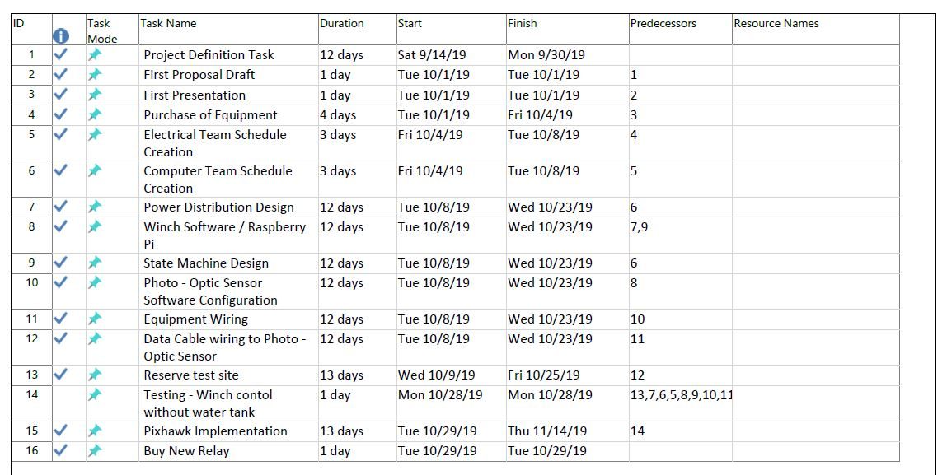

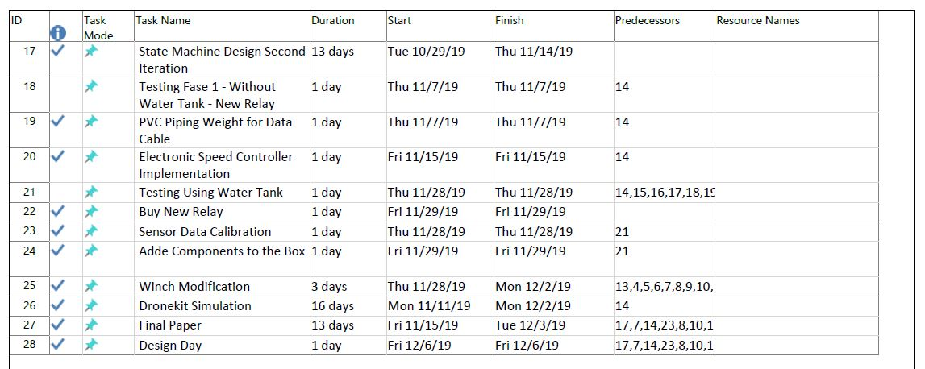

**Figure 8 : Table of Tasks**

**Chapter 3**

**Technical Descriptions of Work Performed:**

**POWER DISTRIBUTION BOARD DESIGN AND IMPLEMENTATION**

Our team was tasked with developing a power distribution board capable of distributing power to a number of devices at different voltages. To accomplish this task, the team began researching DC to DC conversion. The circuit can operate under quite high currents, therefore the team needed to consider efficiency while designing the power distribution board. Through research, the team found that buck converters would be the most balanced DC to DC converters when considering price, efficiency and area. A reliable manufacturer of DC to DC converters is Texas Instruments, they also provide a tool that uses voltage input, voltage output and current output to build a circuit using one of their integrated circuits. The team utilized this tool to create a schematic for 5 volt, 7 volt and 12 volt conversion circuits. The schematics were then reproduced in EAGLE and appropriately connected together. The schematic can be seen below in **Figure 9**. The team ordered the necessary components, assembled the circuit and began testing. The results of which can be found in **Successes and Failures**. Finally, to wrap up the design process for the power distribution board, the schematic was generated in EAGLE’s board layout tool. The board is designed as a two layer, 1.6mm, 3 inch by 3 inch, 1 oz copper board. The traces were laid out and the copper pours were generated. The final PCB design for the power distribution board can be seen in **Figure 10.**

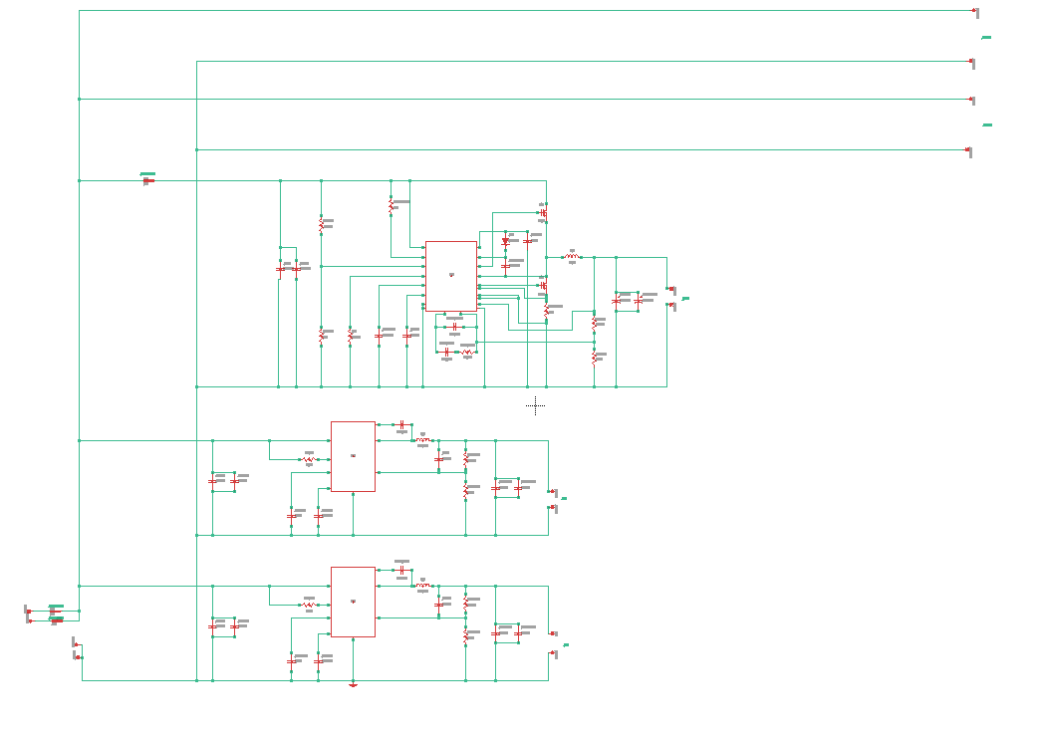

**Figure 9 : Conversion Circuit**

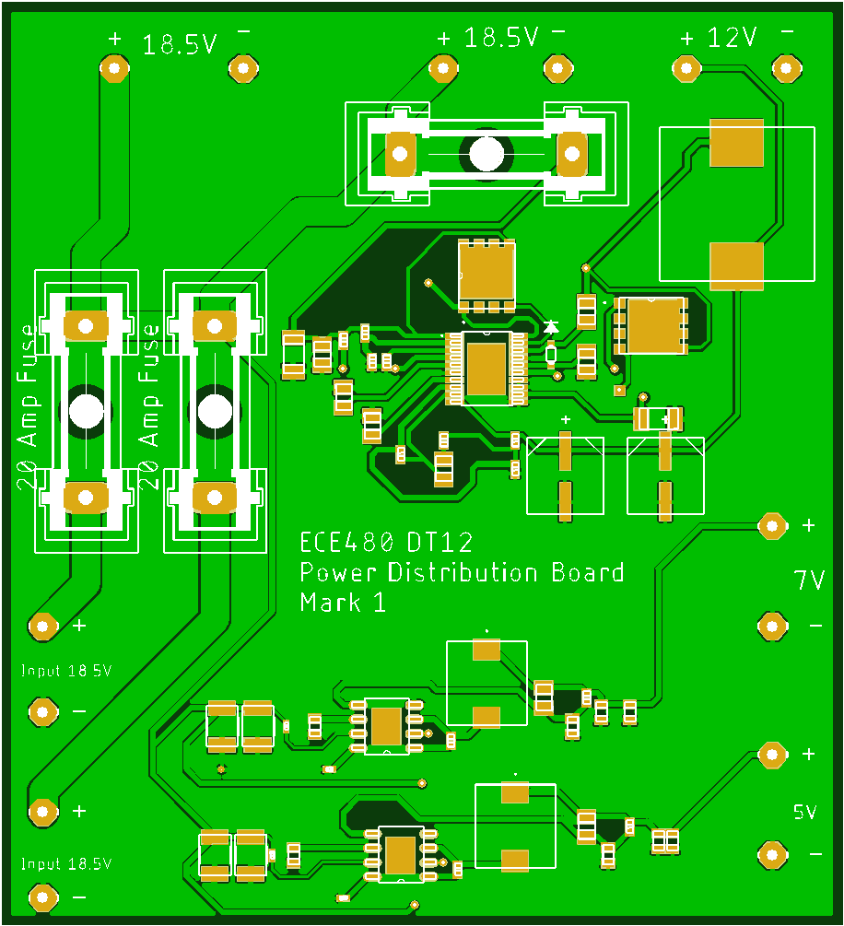

**Figure 10 : PCB Power Distribution Board**

**WINCH HARDWARE DESIGN AND IMPLEMENTATION**

The entire project revolved around the winch itself. The winch was provided by the sponsor but needed several key alterations to fit the proposed design. First, to automate the system’s mechanics the team had to do away with the physical “*up*,” “*down*”, and “*off*” buttons on the winch. This turned out to be one of the largest challenges of the project, as it was completely missed in the proposal. But in terms of automation it made complete and total sense to not have to physically depress any buttons on the winch. Furthermore, the system deals with relatively high current transmission, and it cannot afford any more power usage than completely necessary. After careful research, the team had determined an electronic relay was the necessary solution. A relay is simply a switch controlling a high-current circuit with a low-current signal. The first relay ordered was a two channel relay with the team believing that one channel would be needed to control “up,” and the other channel for “down.” The team happened upon this logic because they had found the following wiring scheme would result in the winch moving up: the positive terminal of the battery to the positive terminal of the motor and the negative terminal of the battery to the negative terminal of the motor. The opposite, where the winch-battery wiring goes positive (terminal)-negative and battery-winch wiring goes negative-positive, would result in the winch moving down. Therefore, the relay should be able to shift between these two states until the desired depth is achieved. Unfortunately, this method failed to take into account the third state of the winch: off. And with the two channel relay the team had already ordered, a change in hardware was needed. Fortunately, to upgrade to a four channel relay was relatively inexpensive. The new four channel relay allowed for functionality in all three commands, and once it was wired up to the battery, the obstacle had been overcome. Now, instead of the battery feeding directly to winch’s motor, the battery connects directly to a 4 channel relay and indirectly to the motor.

Another unforeseen challenge that came up with the winch was speed regulation. Previously, the winch would operate at full speed when turned on. This caused major problems with testing because the pool the team had access to was only about 4 feet deep, meaning the winch would reach the bottom in a matter of seconds; this was much too quick for the pressure sensor to interface with the Pi and, subsequently, the Pi to the winch. To overcome this challenge, another hardware implementation was necessary – this time, a speed controller. To slow down the speed of the winch, the speed controller simply uses a potentiometer to increase or decrease resistance to the motor which, in turn, decreases or increases speed, respectively. This speed controller hooks up directly to the battery to regulate resistance, and it turned out to be instrumental in the success of the project.

The final challenge to the winch was a purely mechanical problem. The spool of the winch, which was supplied by the sponsor, was not hollow and, therefore, could not reel up/down on one side while being cemented into the Raspberry Pi on the other. In other words, one end of wire cannot be spun on a spool while the other end is stationary and connected to the Raspberry Pi. To overcome this, the team decided on the implementation of a slip ring. The inside of the spool also had to be excavated with a drill press so that the data cable could snake through the very middle of the spool. This operation, paired with the slip ring, now allows for one end of the wire to spin with the winch, while the other remains firmly grounded into the Raspberry Pi. Once all these challenges had been controlled, the winch finally provided the proper functionality the team had been tasked with. Going forward, all that was left was the software synchronization with the pressure sensor and the PixHawk controller.

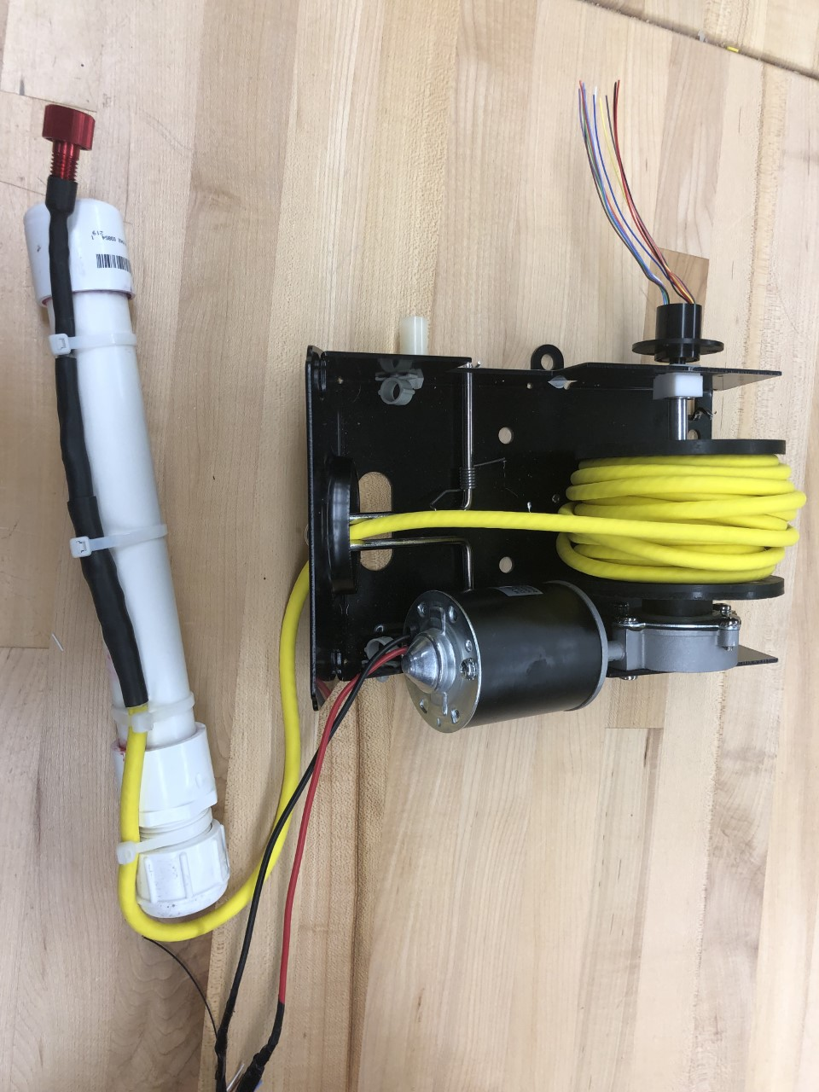

**Figure 11: The complete winch system showing pressure sensor at one end with stationary wires (to be connected to Raspberry Pi) through the slip ring at the other.**

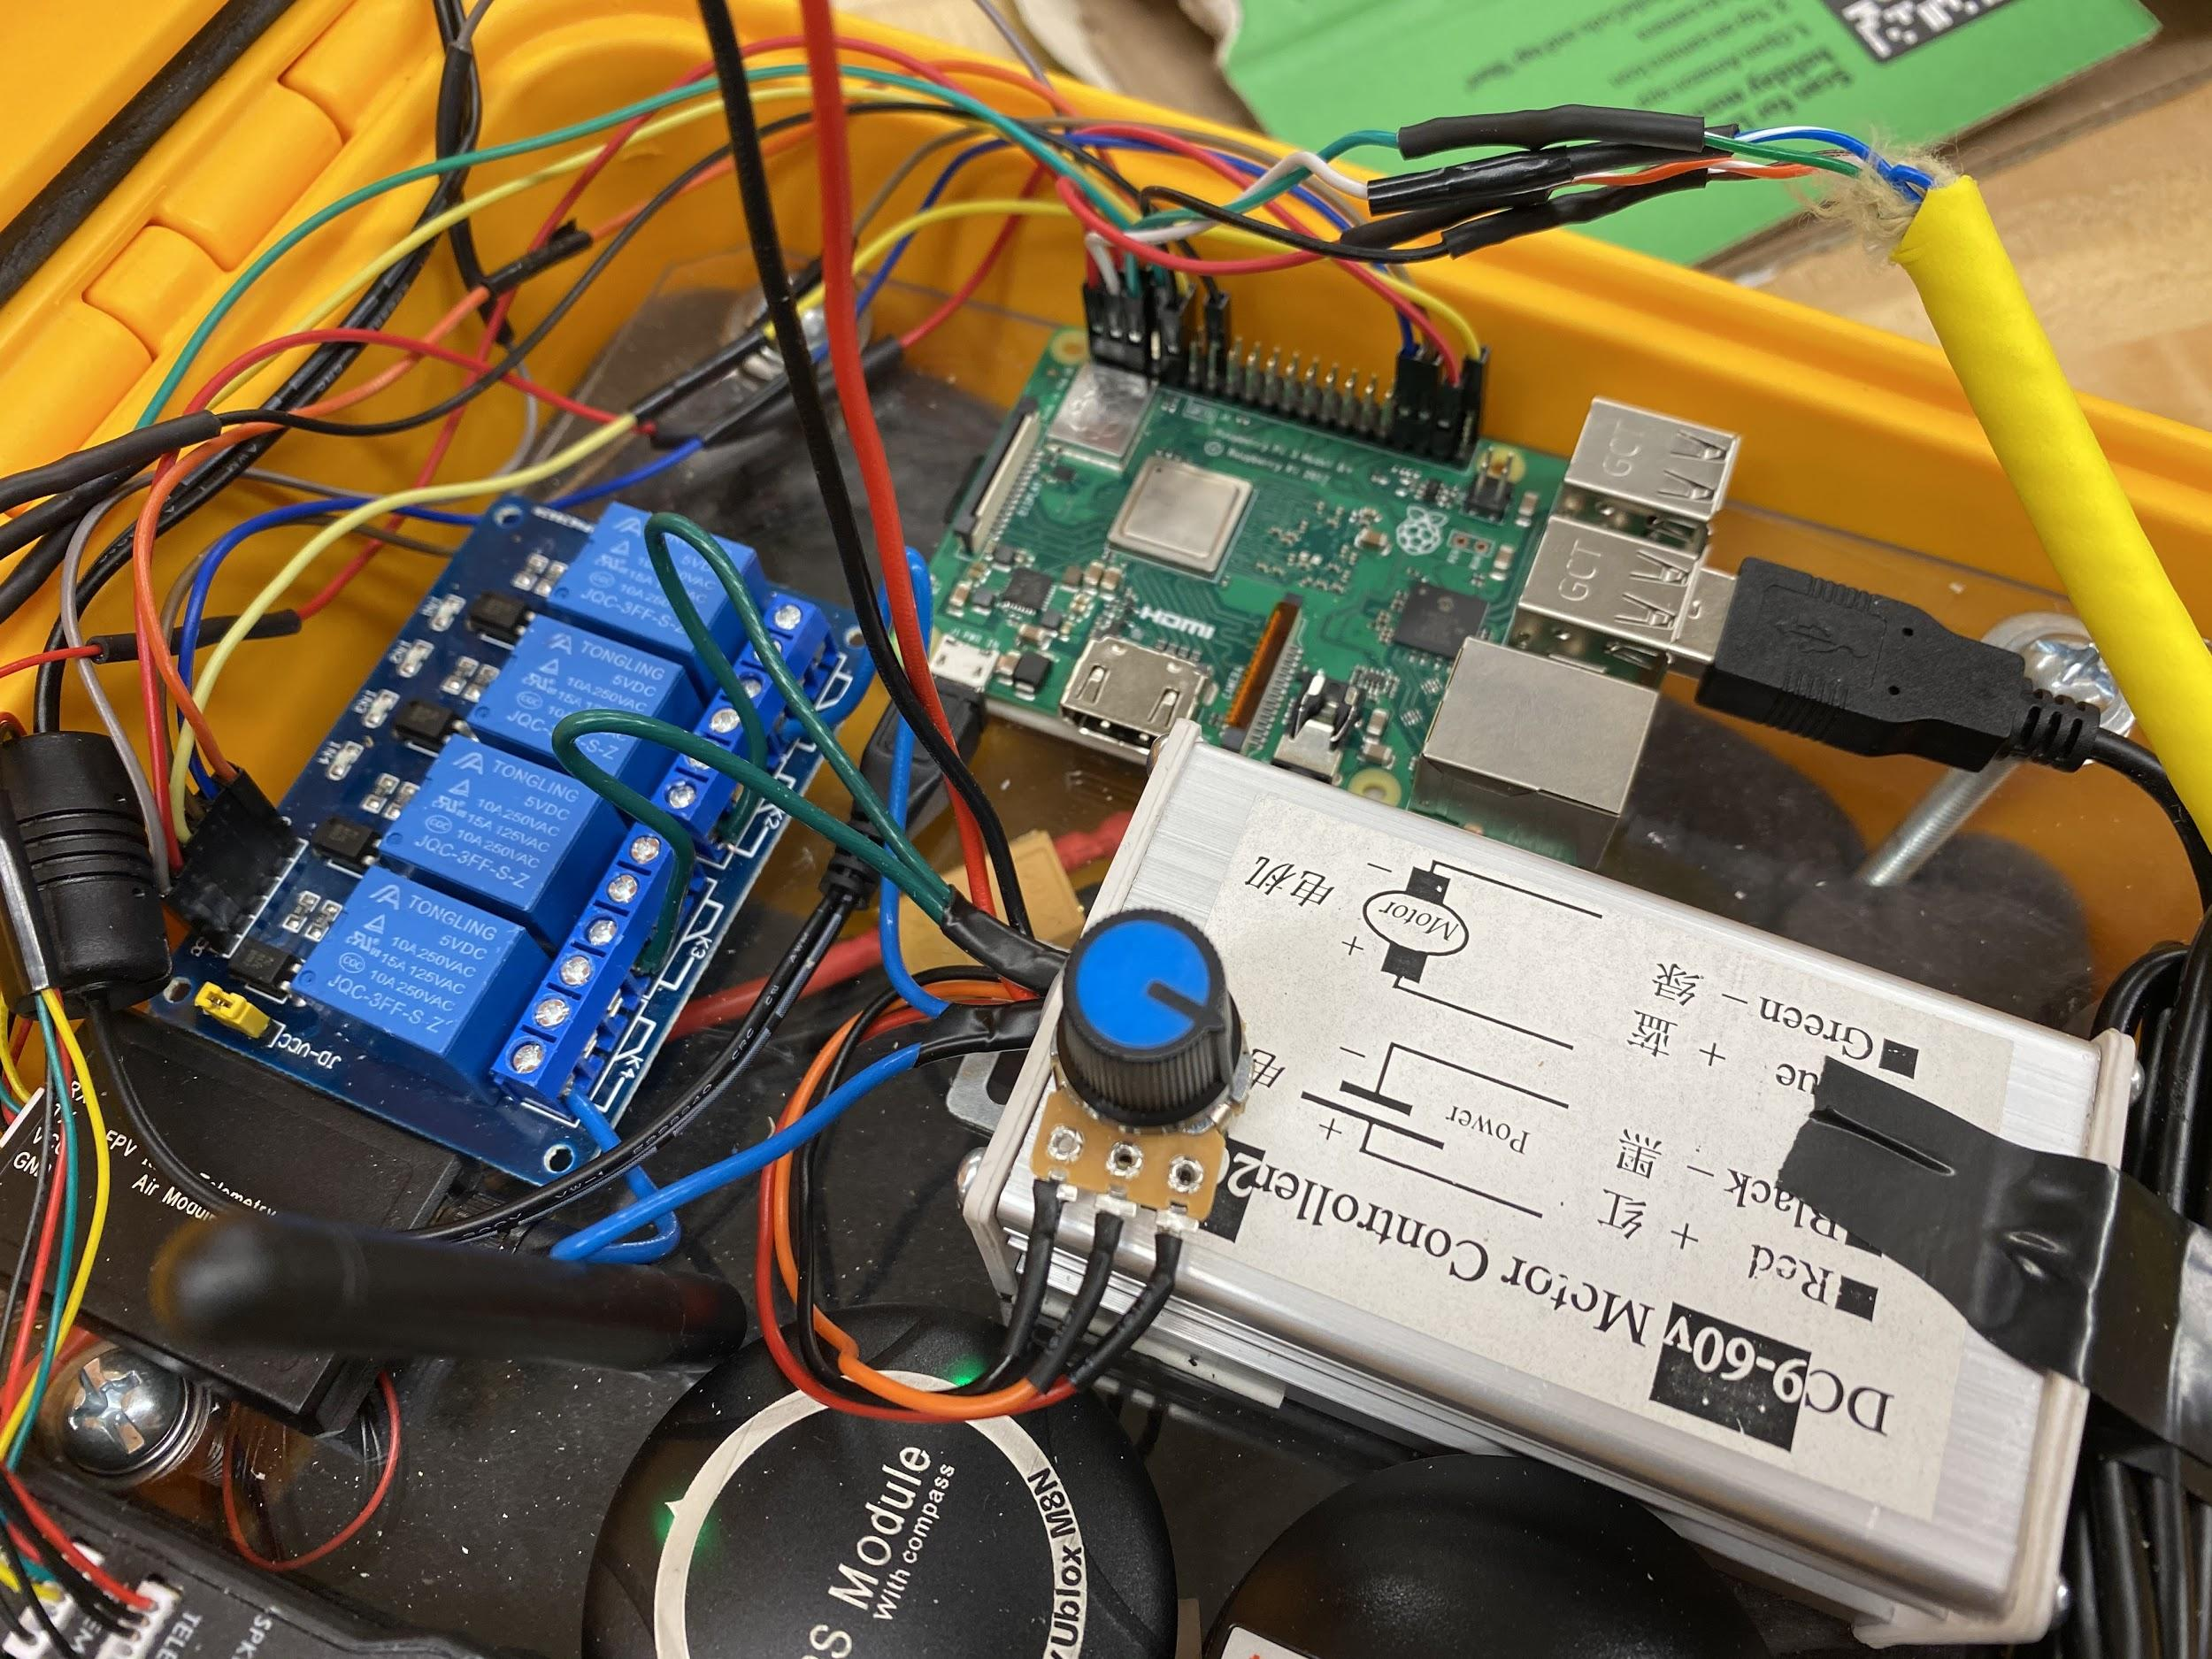

**Figure 12: The electronic speed controller (right), relay(left), and Raspberry Pi (middle)**

Additionally, a weight was made that was used to weigh down the pressure sensor while in the water so that it could minimize any unnecessary movement from external forces. This was made out of simple PVC piping filled with metal pellets and attached to the end of the pressure sensor. The team also soldered on female connectors at the end of the cable that will pin directly into the RPI.

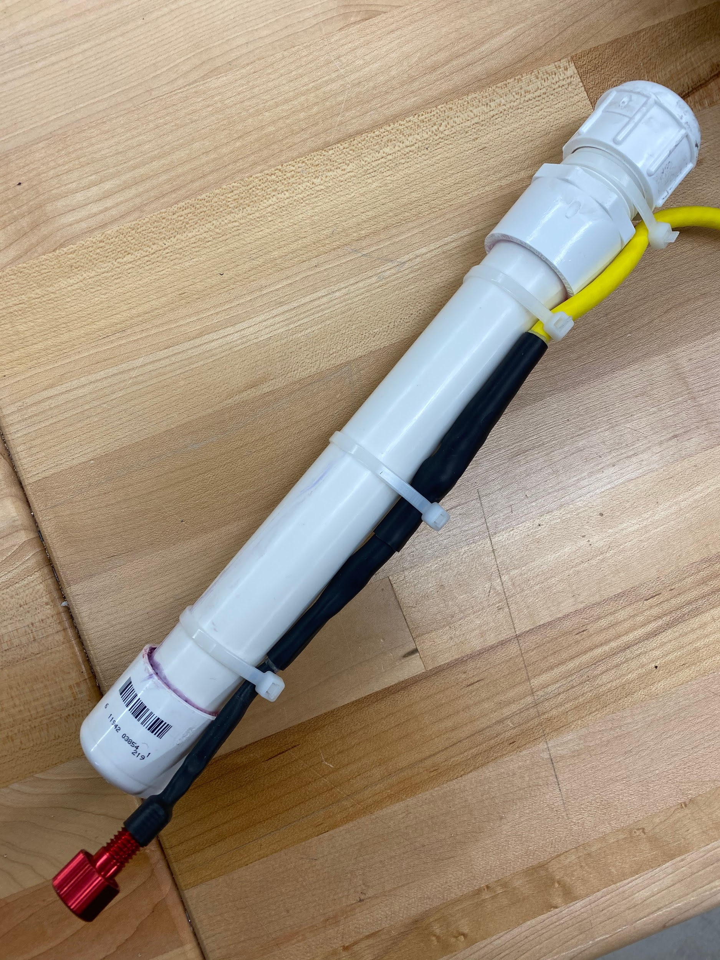

**Figure 13 : PVC piping and sensor**

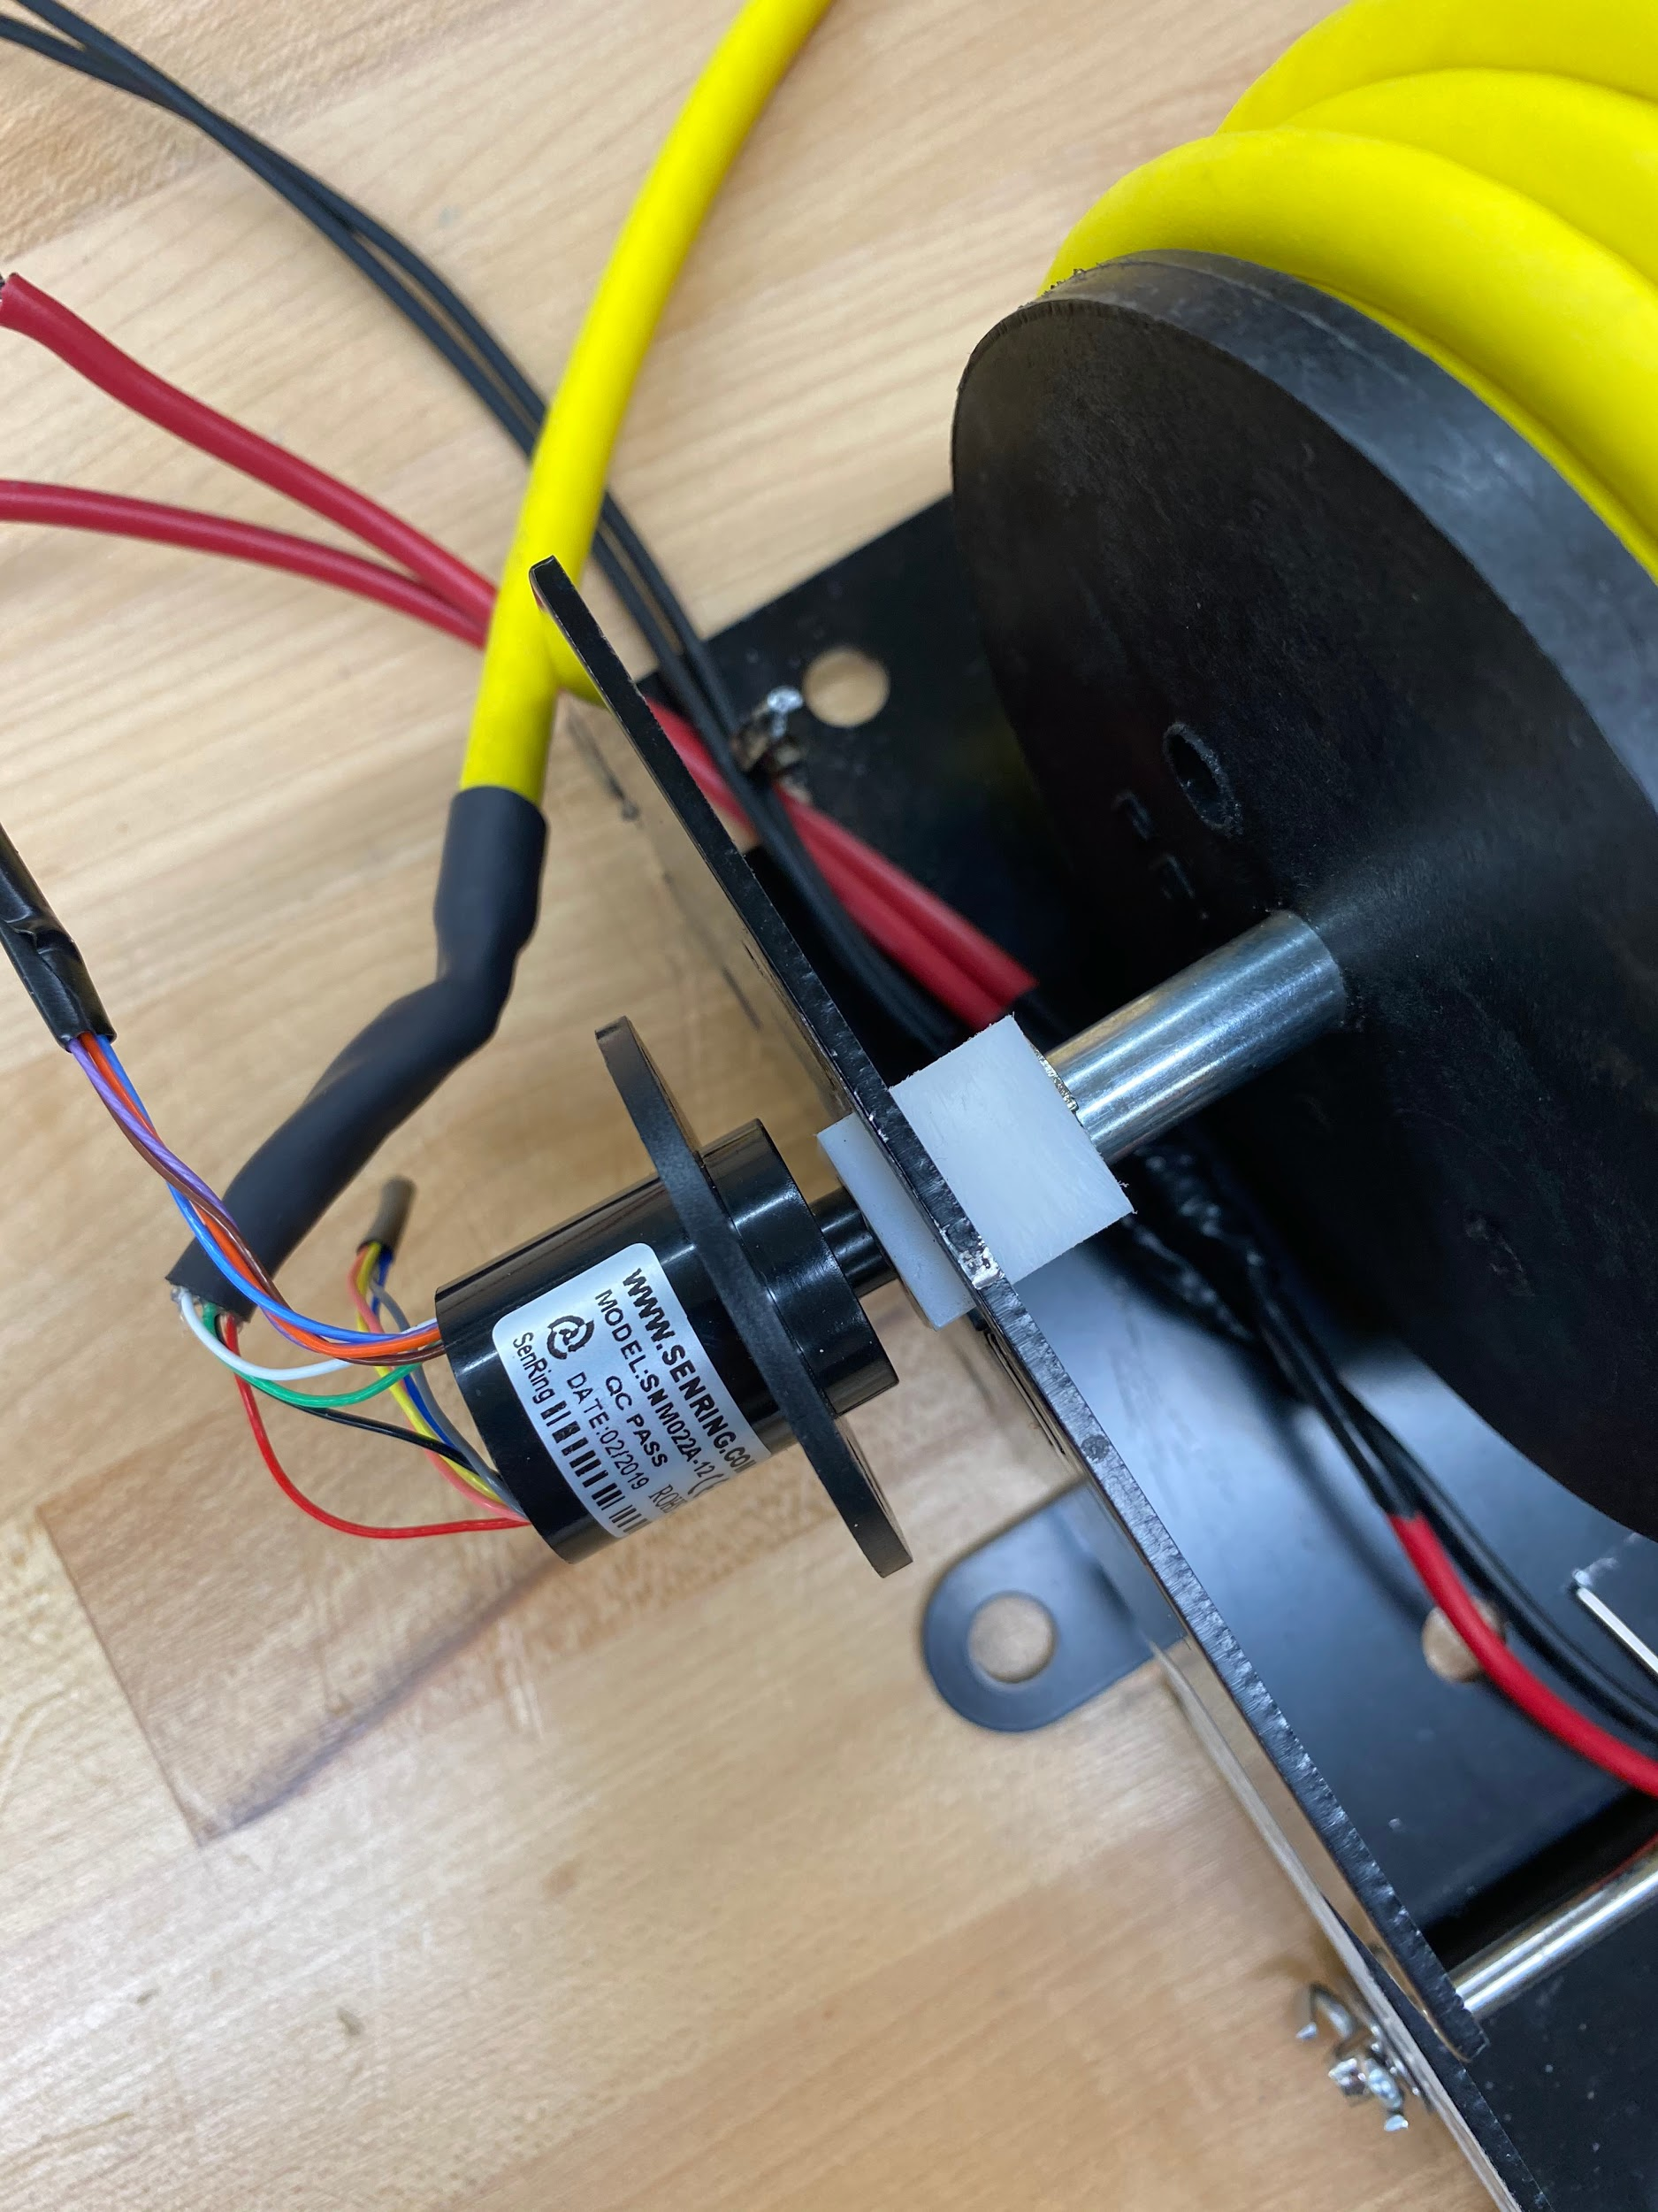

**Figure 14 : Winch with soldered data cable and slip ring**

**WINCH SOFTWARE AND INTERFACE DESIGN REQUIREMENTS:**

As discussed in the previous chapter, the software for the automatic winch system was broken up into several subsystems. Among these are the state machine to control the system logic,

The state machine was decided as the centerpiece of the automated winch system software from the beginning of the project schedule. All other planned software components were ideated to support the functioning of this software state machine.

Essentially, the entire logic of the system must be executed on the Raspberry Pi automatically as input is received from other subsystems. These inputs are depth information from the depth/pressure sensor and location information from the PixHawk and/or GPS module. Therefore, separate software solutions were developed for the Raspberry Pi to (1) interface with the pressure/depth sensor, (2) retrieve and parse location data from the GPS module, and then (3) output signals over GPIO pins to properly switch the relays to control mechanical movement of the winch itself. All three of these subsystems were then integrated into a single solution with an intuitive user-facing GUI solution for sending desired location and depth commands from the host computer to the Raspberry Pi.

The need to transmit these location and depth commands wirelessly from the host computer to the Raspberry Pi justified the additional implementation of a communication subsystem to allow this data transmission. The communication system must be secure and reliable over large distances when the autonomous winch system is deployed for sampling in a lake.

**IMPLEMENTATION OF WIRELESS COMMUNICATION BETWEEN HOST COMPUTER AND RASPBERRY PI**

Originally, wireless communication between the host computer and Raspberry Pi was planned to be completed using an XBee radio communication system. The implementation of the XBee was specified optional and low-priority by the sponsor early in the schedule. Because of this and the expanded scope of other parts of the project, the XBee module was not added to the project during the semester.

Instead, wireless communication between the Raspberry Pi and host computer was implemented over a wireless LAN setup. For testing in the engineering building of Michigan State University, the Raspberry Pi’s MAC address was registered with Division of Engineering Computing Services (DECS) and the machine was assigned a unique, static hostname. This allowed secure tunneling of traffic between the Raspberry Pi and host computer using the Secure Shell (SSH) protocol.

This was highly satisfactory for testing the automated winch system in the engineering building test site. WiFi allowed for functionality which may not have been feasible with low data transmission rates of XBee. For example, the high data rate of WiFi allowed for X11 display forwarding from the Raspberry Pi to the host computer. This flexibility in turn allowed for the development of a GUI application to control and send commands to the winch systems.

**STATE MACHINE DESIGN AND IMPLEMENTATION**

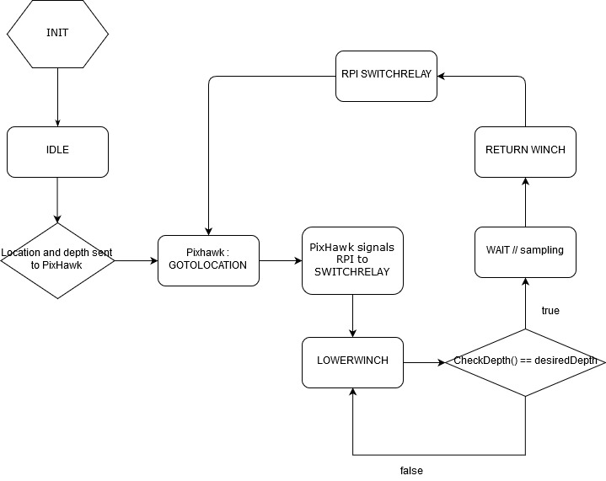

**Figure 15: State Machine Flowchart**

As mentioned, the crux of the autonomous winch system’s ability to be autonomous comes from the state machine which dictates its logical operation based on sensor inputs from the GPS module and depth/pressure sensor. A major issue was encountered during implementation of the state machine. Due to the design of interconnected system between the relays, battery, and Raspberry Pi GPIO pins, a major risk of shorting (and frying) the relay board was introduced. On the board, there are four relays and two are turned on by the Raspberry Pi at any given point in proper operation. However, out of these six possible pairs, two create a short between the relay and battery. The same occurs when all GPIO pins are set high as well.

As a result, ambiguous states in the state machine and incorrectly setting all GPIO pins to high on system startup, fried two relay boards during implementation and testing. Replacement relay boards were ordered to recover from these incidents and major priority was given to ensure this would not occur again. When deployed on the ASC out on a lake, a fried relay would be extremely detrimental to the system, potentially causing the winch to operate indefinitely and “steal” power from the thrusters. To ensure this risk was eliminated to the best of the team’s ability, special care was put into ensuring that there is no logical state in which these relay pairs would be turned on at once. At both software startup and exit (even in case of a crash), function calls were placed to ensure relevant GPIO pins are set to low. States were also clearly implemented to make it impossible for offending relay pairs to be switch high at once. After rigorous testing, the team is able to ensure that there is little-to-no possibility of relays being fried due to this same error in the future.

**GRAPHICAL USER INTERFACE (GUI) DESIGN**

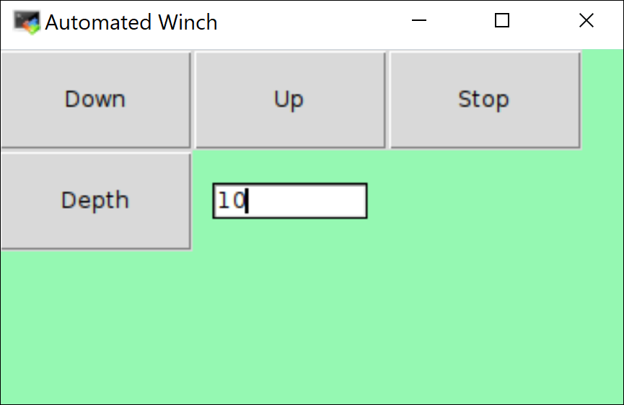

**Figure 16: GUI interface of winch control software**

The graphical user interface shares of a minimalistic design as the main intent is to create an easy and intuitive user experience. Though the winch control software can be executed via terminal, but it has been proved inefficient to directly type every single command instruction in order to control the winch. During software testing it was noticed that command instructions for the winch can easily be misspelled, requiring the user to retype the instructions therefore creating a slow and repetitive workflow. Repetitive workflow during a realistic use of the winch outdoors would likely make the user interaction tedious, perhaps frustrating. A solution to this possible drawback was to create a user interface composed of four buttons and a text field. The four buttons that compose the user interface field allows the user to securely input a depth value in the text field, and execute a winch instruction by pressing on the depth button, therefore communicating with the source code in order to bring the sensor to the desired depth. The design choice of adding a forced stop, down or up button proved to be necessary as the winch was designed to be used in water outdoor environments. Outdoor environments can be unpredictable at times, and given a situation that the winch sensor was being drafted to an undesired part of a body or other unpredictable situation the witch operator can execute one of

the three commands provided by the button user interface. Other important design choice referred to a notification of a button being clicked. Possible choices referred to a screen notification message, but it would prove impractical as a message would add a level of complexity to figure out which button was pressed, therefore breaking the objective of making the graphical interface user friendly. The following design problem was solved by changing the color of the button to red when clicked, and changing it to gray when other button is clicked instead. In addition when a button is hovered by the cursor the button color is changed to red in order to give a visual notification of what button is being hovered.

|  |  |
| --- | --- |
|  |  |

**Figure 17: GUI interface button color change**

**GRAPHICAL USER INTERFACE (GUI) IMPLEMENTATION**

The graphical user interface uses the standard python module Tkinter which is included with standard Linux, Microsoft Windows and Mac OS X installs of Python. The user interface window is created by the use of the class Tk( ). The Tk( ) class is created without arguments, and stored in a variable called window. This was done in order to use Tkinter methods geometry, title and configure. Being that geometry was used to set a fixed window size that the software is running on, title was used to keep the name of the software at the top of the window, and configure was used to set a background propriety therefore allowing to personalize the background with the color shade of green ( #95f8b2). Without the use of the method mainloop( ) the software window would not stay open for indeterminate time until the software is manually closed. The interface buttons are created by using the Tkinter widget button. The widget button gets called and attributes for the button are provided. Widget buttons allow color, text and call attributes. Therefore every button call a function that executes a desired winch command.This means that when the button depth is clicked, the software calls a function created on a separate file that its soul purpose is to move the winch at the prompted depth.

**INTERFACING WITH DEPTH AND PRESSURE SENSOR**

The depth/pressure sensor used for this autonomous winch system was a Bar30 high-resolution sensor from Blue Robotics. The interfacing solution between this component and the Raspberry Pi was made easy through a Python2 library provided by the manufacturer. This library contained function calls to handle I2C communication with the sensor and display well-formatted pressure, depth, and temperature readouts to the terminal is a plethora of units, as well as conversion between freshwater and saltwater depth. An example of continuous readout provided by the library can be seen in **Figure 18**.

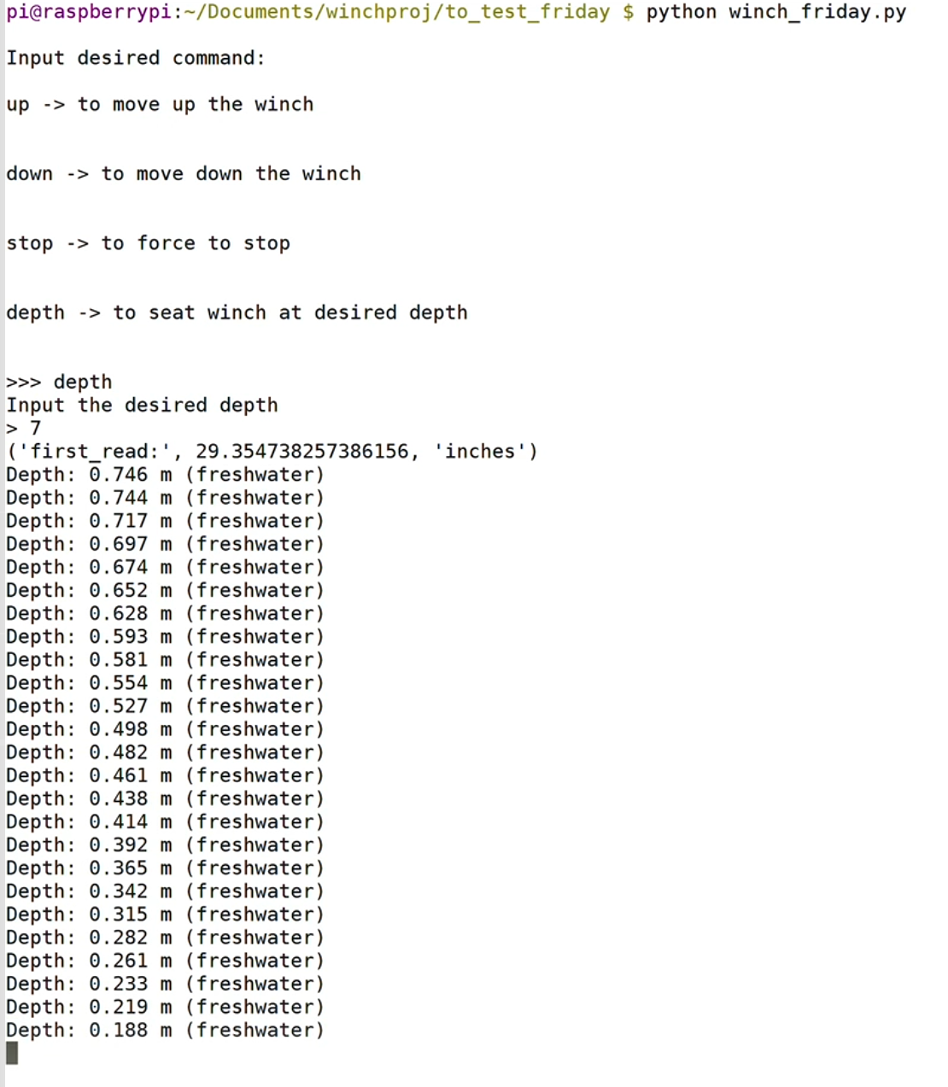

**Figure 18: Terminal readout of winch control software**

**PIXHAWK IMPLEMENTATION**

The Autonomous Surface Craft that will utilize the winch system uses a Pixhawk flight controller to control the movement of the craft on the water.

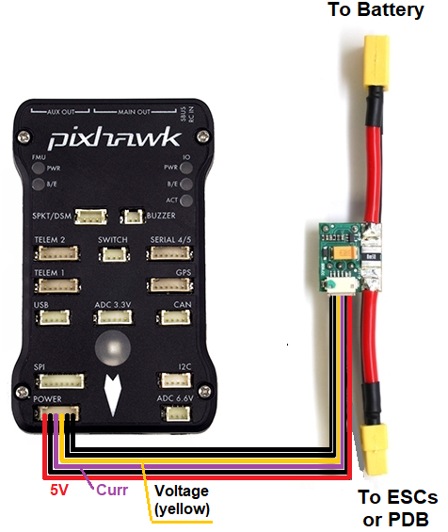 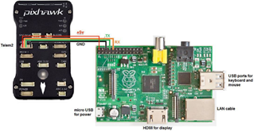

**Figure 19:** Pixhawk to batter**y** **Figure 20:** Pixhawk to microcontroller

**Figure 19** shows how the Pixhawk is powered. The Pixhawk has a built in port that connects to the Pixhawk power module. The power module connects directly to the battery on one end, and to the Power Distribution Board on the other using a XT60 cable. This does not provide power to the Pixhawk Servo Rail, as that must be powered separately. **Figure 20** shows how the Pixhawk connects to the Raspberry Pi. There is a 5 Volt power connection from the Pixhawk to the Raspberry Pi. This connection allows the Pixhawk and the Raspberry Pi to be powered by the same power source. There are also TX and RX connections between the two that allow communication. This communication is done using Mavlink protocol.

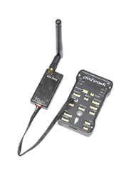 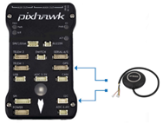

**Figure 21:** Pixhawk to telemeter **Figure 22:** Pixhawk to GPS

**Figure 21** shows the connection between the Pixhawk and the telemetry device. Another telemetry device will connect to the host computer, and this allows the host computer to connect wirelessly to the pixhawk. **Figure 22** shows the connection between the GPS/Compass. Once the host computer connects to the Pixhawk, the Pixhawk can then be controlled by Mission Planner, QGroundControl, or some other Ground Control Station (GCS) software. The GCS shows the GPS location on a map, the speed, altitude, and the path of the boat. Commands can be entered directly into the GCS while the boat is armed, or a pre-chosen waypoint path can be entered. Python scripts can also be used to control the boat. Since the physical boat was not ready while we completed this project, we had to simulate the movement of the boat using Python Dronekit.

**DRONEKIT SIMULATION**

Python Dronekit is an open source software tool that allows users to control a drone, plane, rover, or Autonomous Surface Craft using a python script rather than manually typing commands into a GCS. Dronekit also has a Software in the Loop (SITL) package that allows these python scripts to run simulated vehicles instead of real ones. This is extremely useful for testing purposes, as it can demonstrate whether your scripts are running as desired without risking damage to your vehicle. For this project, the dronekit simulation was done in an Ubuntu Linux virtual machine, QGroundControl, and Raspberry Pi.

To start the process, Dronekit, Dronekit-sitl, future, mavlink, and MAVProxy python libraries had to be installed on the host computer. Dronekit and MAVProxy had to be installed on the Raspberry Pi. To run the software, a Dronekit-sitl command is run in the terminal, as shown in **Figure 23.** This command sets a home location for the ASC, and then waits for a connection from MAVProxy.

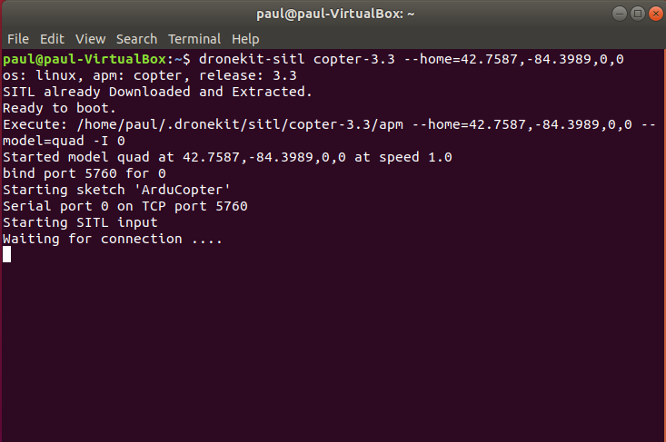

**Figure 23:** Dronekit-sitl command: Waiting for connection

In another terminal, a MAVProxy command is run as shown in **Figure 24**. This connects via Transmission Control Protocol (TCP) to dronekit-sitl, and opens up User Datagram Protocol (UDP) connections for the GCS and Raspberry Pi to connect to.

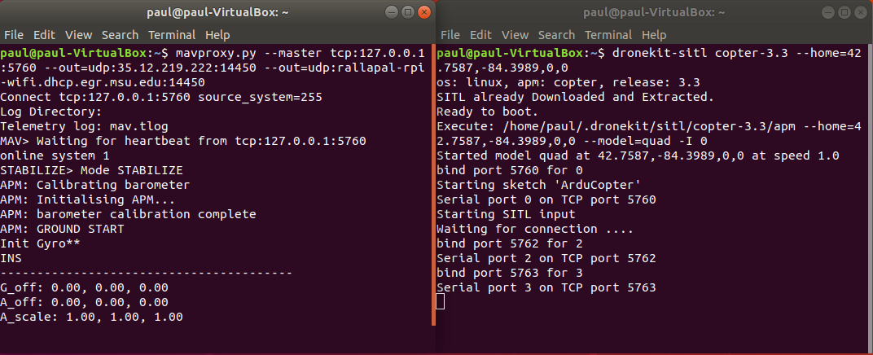

**Figure 24:** MAVProxy Command: Outputs are set, and connection is made to dronekit-sitl

In QGroundControl, when a UDP connection is opened, the software will automatically connect to the simulation**.** Once connected, an SSH client is opened to connect to Raspberry Pi to run the python script. As shown in **Figure 25,** the latest script arms the ASC, and prompts the user to move the ASC and deploy the winch to a specific depth, to operate the winch manually, or send the ASC back home and disarm.

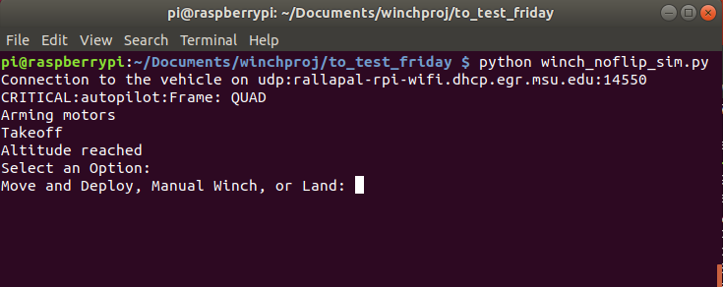

**Figure 25:** Raspberry Pi runs a python script to control the ASC or the winch

If the option to move the ASC is chosen, the program displays the current latitude and longitude and prompts the user for a new latitude and longitude, a speed to move the ASC, and depth to deploy the winch to. This command will move the ASC to the new location as shown in **Figure 26**, and once stopped, it will deploy the winch.

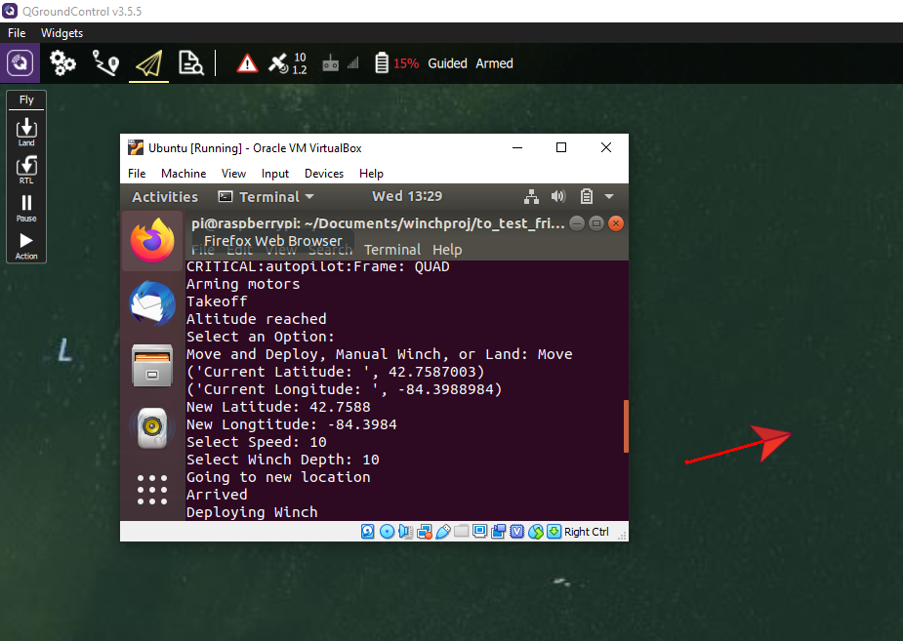

**Figure 26:** Choosing a latitude, longitude, speed, and depth

moves the ASC and deploys the winch

The ASC cannot move while the winch is deploying, and the winch cannot deploy while the ASC is moving. This protection was added in the code to prevent overdrawing the battery when the physical ASC is ready. The winch can also be operated manually with this python script, just as it is run in **Figure 18,** but not while the ASC is moving.

**Chapter 4**

**TEST DATA**

The sponsor of this project, the MSU Smart MicroSystems Lab, asked the team to ensure that the accuracy of the winch was within +/- 2 inches. This is because SML’s objective is to triangulate the location of the fish to the highest degree of accuracy as possible. If the user tells the winch to drop the sensor 30 inches underwater and the sensor drops to 21 inches, the calculation will be significantly off, giving inaccurate results. To combat this, the team ran a test to determine and correct the accuracy of the depth sensor/winch combo. The procedure was as follows. The team set up the sensor and winch at the SML’s tank. The team taped a measuring tape on one of the tanks see-through, acrylic walls precisely at the waterline. One team member operated the winch while the other carefully observed the sensors depth within the tank. The team member operating the winch would change the depth according to the other team members commands. Placing the sensor in one of three ranges: 0-13 inches, 14-26 inches or 27-40 inches. A third member recorded the actual depth of the sensor according to the tape measure as well as the calculated depth according to the depth sensor. The first of these results can be seen **Figure 28 and Figure 29** and are the pre-calibrated data drawn from these experiments.

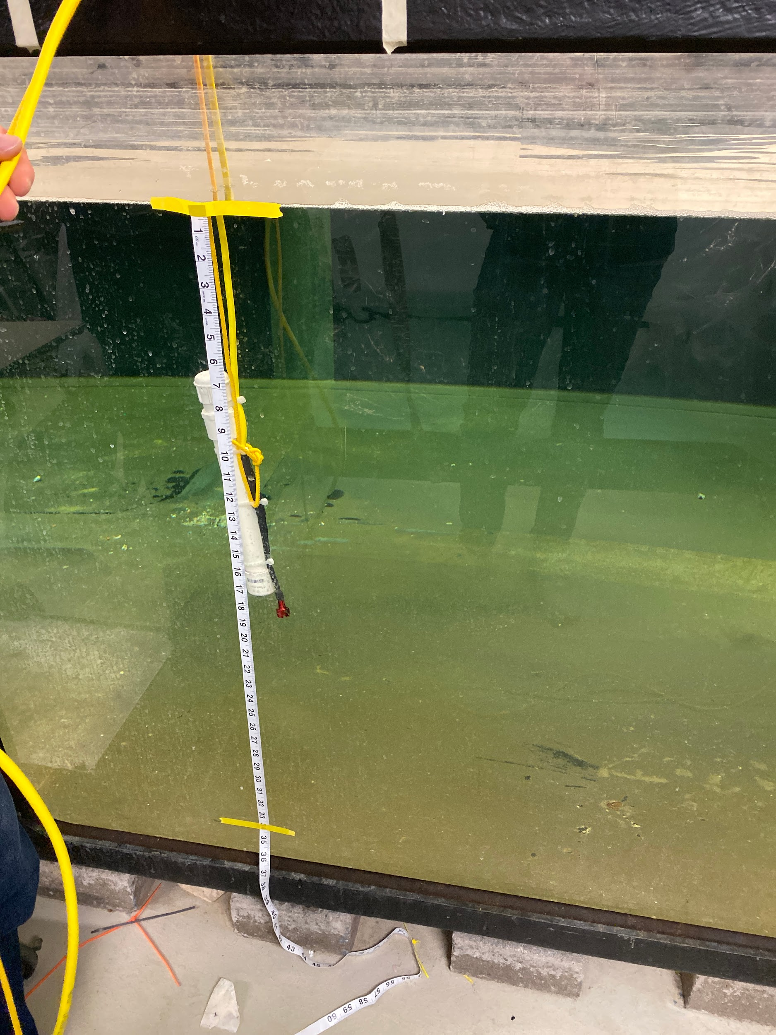

**Figure 27: Sensor deployed during testing**

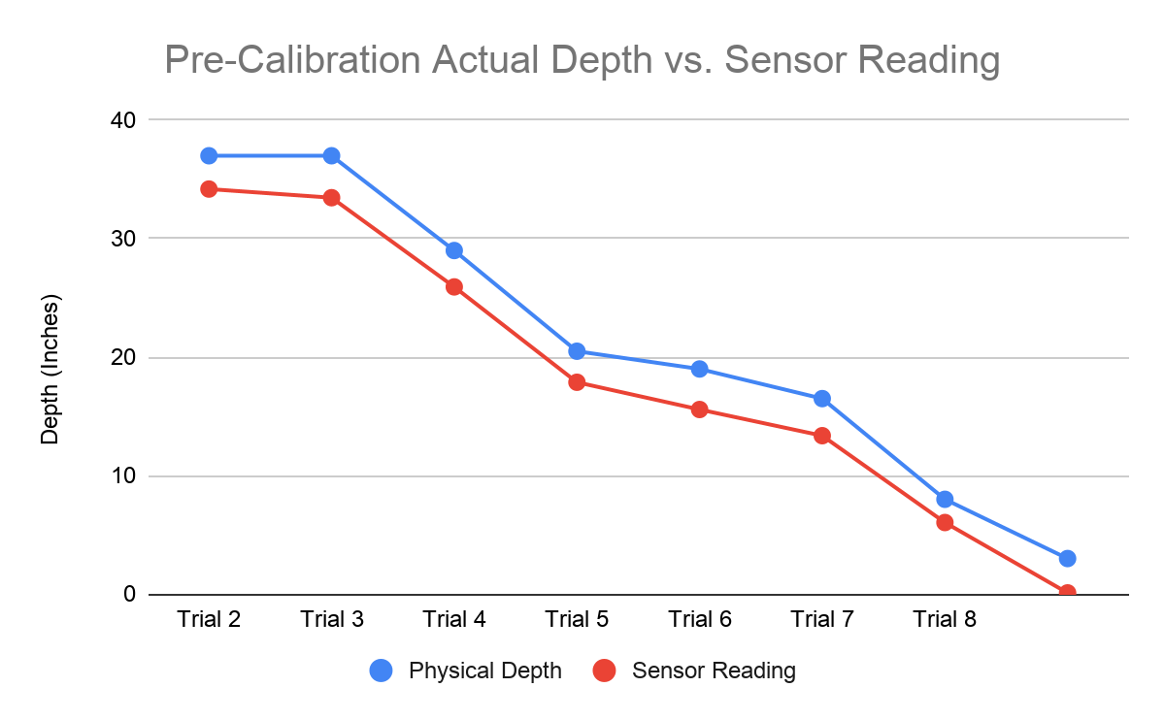

**Figure 28**

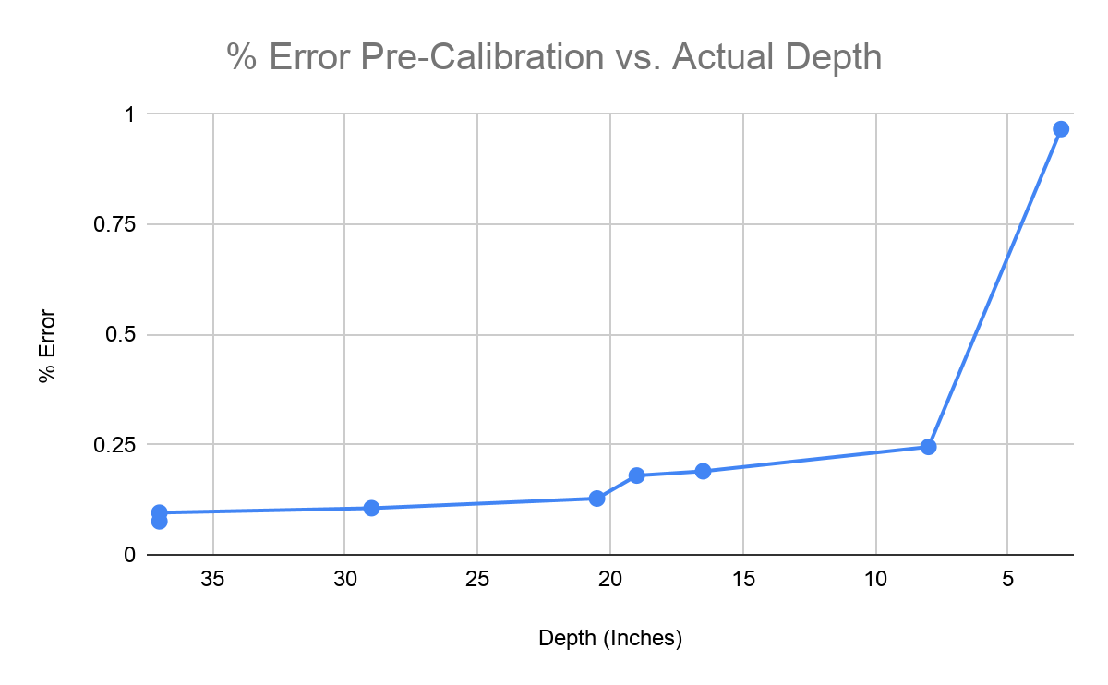

**Figure 29**

From this point the team was fairly pleased with the result. For 0-13 inches, the average difference was 2.48 inches, for 14-26 inches, the average was 3.05 and for 27-40 inches the average was 3.14 inches. These results were close to the team’s goals, however, further action was necessary. The team calibrated the sensor, restarted the program and ran through the exact process again. The post-calibration data is shown below in **figure 30 and figure 31.**

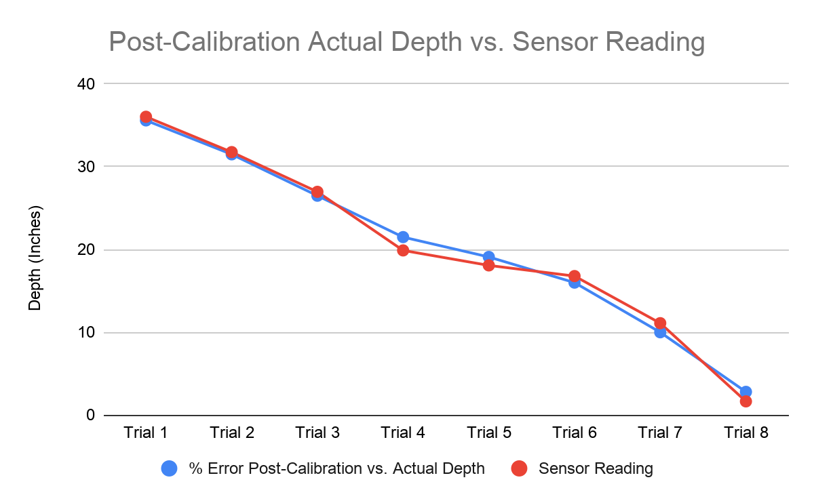

**Figure 30**

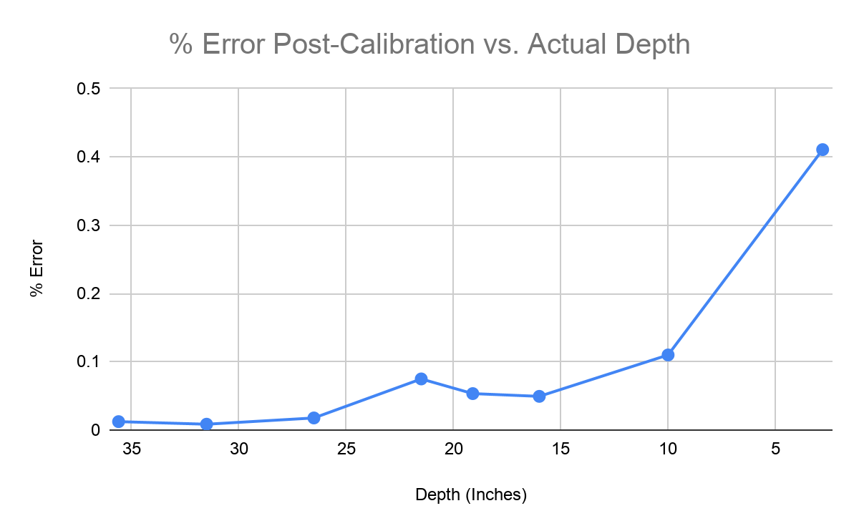

**Figure 31**

This time, the results were much more accurate. For this set of trials, 0-13 inches had an average difference of 1.15 inches, 14-26 inches had an average difference of 1.315 inches and 27-40 inches had an average of 0.355 inches. It was observed that after calibration, as the sensor got closer to the surface, the sensor was less accurate.

**Chapter 5**

**FINAL COST**

The final cost of this project did go over budget from our initial estimates. There are several reasons why this happened to include adding parts we did not think of beforehand, needing new pieces of equipment to solve issues, recurring costs incurred from testing, and the cost of shipping our parts. On top of reaching the limit of our sponsor funding, we also spent some out of pocket money to allow for faster purchases from local and internet sources. Most recurring costs stemmed from doing multiple tests on our power distribution board. Due to the high voltage and current of the system it was easy to accidentally short our relays and need to order additional testing parts. Another issue we encountered was the tracking system used by the engineering department. One large cost order we placed was not included in our tracking which caused us to have a discrepancy in our budget tracking. This was corrected in our final cost reporting.

The final cost of our project without shipping costs and extra parts comes out to be $343.42. This includes the cost for all the navigation equipment, data collection equipment, and our power distribution system. The hull of our boat, the winch, and the batteries were provided to the team by the sponsor.

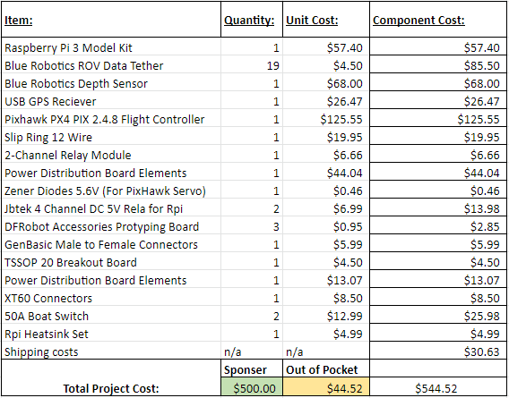

**Figure 32: Final Budget**

**SUCCESS AND FAILURES**

The automated winch project presented us with a multitude of challenges from the start. The most obvious challenge came not from the technical work, but from the size of our team. Our seven member team was the largest group formed this semester and presented the issue of proper workload distribution. The design of our project was relatively simple and would have been easily constructed with a smaller team. The issues came up when having different people work on different aspects of the projects. The electrical engineer majors focused primarily on the hardware aspect while the computer engineers worked on the software end of things. This proved to be successful by capitalizing on the individual strengths of our group members, but slightly detrimental to sharing in the workload. Having a large group made it difficult for each member to get a fair share of technical work when there was not an outstanding amount to be completed. The project was successfully completed and met our goals and expectations, however the learning experience would have a greater benefit with a smaller team.

The technical side of things provided many challenges as well. The bulk of our project centered around the integration of several different systems, to include mechanical winches to programmable microcontrollers. With any larger scale integration project there were initial issues debugging our controller code to properly control the winch. The team ran into the issue of having the controller provide a command but the winch motor would not respond the way it was expected to. With the hard work of our computer engineers, the command codes were debugged which allowed the team to move into our testing phase. Another pressing issue that we ran into was the spool used to hold the data cable. The team’s, and sponsor assistant, did not realize we would have issues connecting our data cable to the RaspberryPi due to the rotation of the spool. This was first viewed as a failure and a large oversight, but we prevailed. Through our sponsor the team was able to meet with a craftsman who was able to modify our spool to our specifications to allow us to connect the data cable to a slip ring. This connection allowed us to transition from a rotating cable to a stationary one with no issues. This was a great success for our team.

Overall the project turned out very well and we met both our sponsor’s goals and our personal goals. The finished project is presented as a unified system which combines aspects of electrical power, circuit design, microcontrollers, and programming. The team faced adversity through the unexpected during this project but innovation prevailed.

**SUGGESTIONS FOR FUTURE WORK**

An incredibly important part of any project is feedback. Without feedback the team, and project as a whole, would take a much longer time to develop the necessary skills to succeed. The project needs suggestions passed on to improve its functionality and help prevent the same mistakes from being made twice. The suggestion which takes the most precedence would be the large team size. As mentioned before, the large team size made it difficult to equally delegate technical tasks which helps culminate a students learning from the past several years of schooling. A smaller team size would allow for more effective technical design changes and testing. Additionally, smaller team size would improve the speed at which a project would move along. Due to the team's large size, it was difficult to coordinate meeting times to run tests or meet with our sponsor. A smaller team would allow for improved project design time, meeting flexibility, and greater knowledge application.

The automated winch project was an excellent project to end our electrical engineering degree with. The system required the application of all core electrical engineering classes, from circuit design to programming. Having a project of such design allowed us to apply all our electrical engineering skills, a task that was not as broad in other team projects. It is strongly suggested that future projects try to incorporate a more balanced amount of electrical engineering specialities.

**Appendix 1**

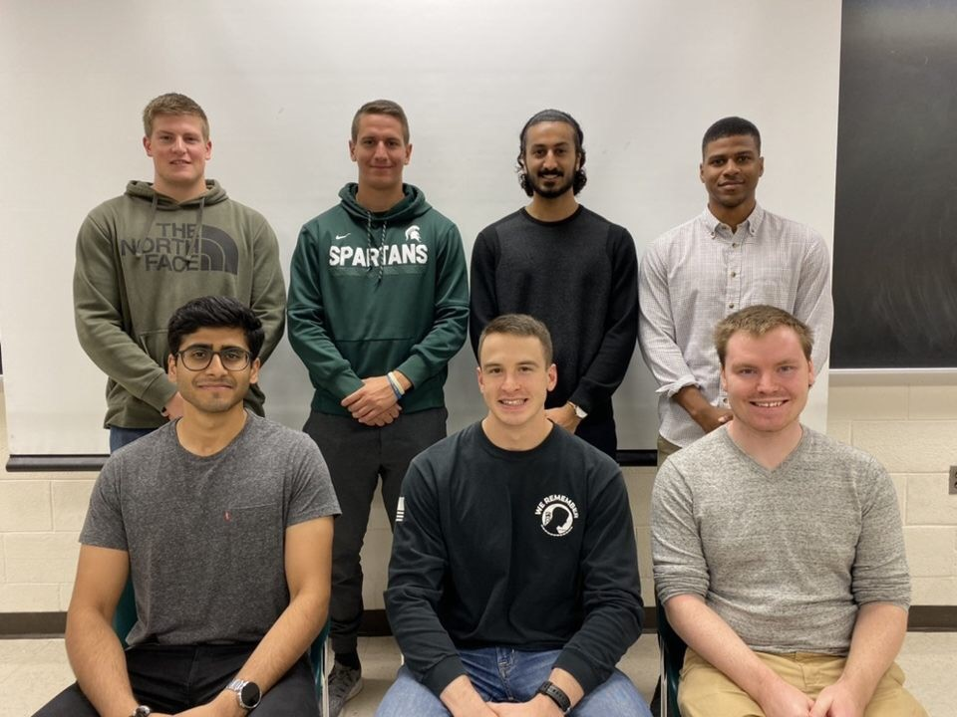

**Team 12 - top row left to right: Nick Alfano, Philip Schmitz, Yacer Mirza, Funakoshi Silva**

**bottom row left to right: Parwesh Rallapalli, Adam Chapman, Paul Hanvey**

**Nick Alfano**

Over the course of this semester Nick has learned a lot about his discipline. Our team took part in the engineering design process and learned a lot as a result. His portion of the project was to manage the design and testing of the power distribution board as well as managing the automation of the winch. Each of these assignments required that Nick partake in the engineering design process. He began with the automation of the winch. To complete this, Nick began by identifying the problem: the winch was controlled with a physical switch that was mounted to its housing. This was a problem because it needed to be operated remotely. To fix this, Nick began researching ways that the team could bypass the switch and control it using the Raspberry Pi that was already going to be mounted. The possible solution that Nick came up with was a four-channel relay that would be controlled by the Pi. Nick searched online until he found components that would meet his needs, ordered them and built his first prototype. The timetable that Nick had setup for this portion of the project was two weeks. Nick accounted for shipping of the component, testing and adjustments. When the part arrived, the team immediately began testing and ran into problems, so the process continued. Nick identified the problem, had our software guys adjust the code accordingly and tested again. This happened a few more times until the team finally came to an impenetrable solution. As a result, the winch can now be accurately controlled using the command line of the Raspberry Pi instead of the physical switch.

This project was not finished within the timetable that Nick had initially established. This was due to the fact that every time the team encountered an error, the team damaged the component. The team were forced to order the component multiple times before the team had a reliable solution. The waiting time on these orders is what ultimately pushed us beyond our deadline. This was still an enormous portion of our project and was an important success. However, there was more to be done in terms of automating the winch. The winch the team received from the sponsor lacked the ability to control the speed at which it lowered or raised our sensor. This led to many issues when it came to our sensor. The problem was easily identified, now Nick had to begin to research possible solutions. What Nick eventually found was a simple pulse width modulator (PWM) module that came with a potentiometer that allowed us the very precisely control the speed of the motor. Once the component arrived, Nick needed to integrate it with our relay, this was not a simple task. Nick had to go through the design process from the start. Nick started by identifying the problem: both the four-channel relay and the PWM could not work together in their current state. Nick began imagining possible solutions to his problem. Once Nick had come up with a solution, he began modifying our components and testing. Thankfully, this solution worked without any failures.

There was one more problem that arose with the winch that Nick identified. The project that the team were given was developed by the MSU Smart Microsystems Lab. They had already come up with some portions of the project that the team could not change. The problem Nick identified was in their design. The project was to use a winch, provided by the lab, to drop a sensor down into the water. To do this they wanted the team to replace the rope that came standard on the winch and replace it with a data cable. One end of the cable had the sensor and would be lowered down into the water, the other end would statically attach to the Raspberry Pi. The problem Nick identified was that this is not possible without major modifications to the winch. Nick began the design process by approaching his team, sponsor and facilitator with this roadblock. It took some convincing, but eventually everyone was on the same page. the team began researching solutions and came up with one. The team sent out the winch to a fabricator to make the modifications professionally. This whole process took many weeks and the winch had finally arrived during the last week. The team will start testing and making necessary modifications immediately.

The final design process that Nick led was the design of the power distribution board. This was a very long process that, admittedly, could has been in a much better way. Nick began the process by understanding what our inputs and outputs were. From there Nick started researching the best solutions and found that buck converters were by far our best option. Nick then began finding IC’s that would fit within our constraints. Next Nick developed schematics for the buck converters and linked them all together. This was all a part of the planning process. Nick then began the longest stage of the design process, prototyping. The planned timetable for the power distribution board was 3 weeks. This accounted for shipping, assembly and testing. This is where Nick ran into many many problems. To begin, the shipping for the components took nearly a week. The components that Nick ordered were small surface mount components so soldering the components took a week. During testing Nick ran into many problems with the circuit not working properly. Nick contacted the IC company, Texas Instruments, for help. This process took about 4 days and did not lead to a solution. Nick decided to order the components again, this time Nick spent a few days tracking down the correct components in leaded form. These components took nearly a week to arrive and again, did not work properly. This is where the time constraints began to limit him. The deadline was 2 weeks out and the lead time on a board was about a week meaning that there was no time for testing of the board. The board is ordered but is not expected to be done in time. If Nick could do it over there would be a number of things he would do differently: Nick would have ordered the leaded components first and earlier, he would have assembled it faster and he would not have waited so long to order the board.

**Philip Schmitz**

What made team 12 unique was that it was the largest group within 480 this semester. This meant the team had plenty of resources to tackle each of the four main topics in the project: power distribution, communication, controls, and sensor/data cable wiring. Given the sheer number of group members, however, there was plenty of overlap, meaning each person had the opportunity to be involved in each area. So, while Philip believe he offered his skills everywhere throughout the project, his main roles were in communication and sensor/data cable wiring as well as being a lead when several unforeseen challenges came about. The beginning of his work consisted of extracting the necessary data from the water pressure sensor. This data would set the foundation for the entire project: the values from it were to tell the winch to increase or decrease in depth. Additionally, Philip worked on waterproofing the sensor to the 50-foot data cable to provide underwater functionality, as specified by our project sponsor. The next area he focused on had to do with the software communication between the sensor and Raspberry Pi. Once the group was able to read in data, the main objective of the project could be started, which was to automate the winch based on a user-given input. The work here consisted purely of coding in Python, which presented quite the learning challenge as it is not in the coursework for electrical engineers. Thanks to great teammates, he was able to pick up the required software knowledge quickly, and he helped write the logic behind the winch’s three main commands: up, down, and stop. The premise of the automation takes in a user-input depth then immediately starts reading depth from the sensor to determine how far down the winch already is. Then, based on the user-input, the code will determine if the winch needs to be lowered or raised to achieve the desired depth. All the while, the physical direction the winch moves is determined by which GPIO pins the code turns on or off on the winch’s relay. A major problem that came up in the project involved the spool of the winch – in this case, the spool was to wrap the data cable, connected on one end to the depth sensor and connected on the other end to the Raspberry Pi. The team soon learned that as the cable wraps up, it is impossible to have one end of the wire cemented to the Raspberry Pi. After much research, the team decided to implement a slip ring to account for spinning on one side. Philip helped implement this capability into the winch itself. Overall, his work blended the perfect amount of hardware and software capabilities, as well as mechanical operations required to rig the spool to fit the design specifications.

**Yacer Mirza**

Throughout the duration of the semester Yacer was able to successfully contribute to various areas of the senior design project to the best of his abilities. As an Electrical Engineer his scope focused primarily on the hardware side of the winch system. At the start of the semester Yacer began his contribution by soldering the wires of the pressure sensor to the cable that would be used on our winch with the help of Philip. This is an important process that is necessary for the group to move on and begin testing. Failure in this part would result in faulty data and a hindrance to the progression of the rest of the group. He also contributed and assisted in the finalization of the wiring and waterproofing of the pressure sensor cable to the Raspberry Pi. Although it is not his area of expertise Yacer also contributed to the development of the software side of the communication between the sensor and the Raspberry Pi. This part of the project was developed using Python. The goal of the said software was to automate the winch based on user given input. A desired depth is inputted and based on the feedback from the sensor the winch will either move the sensor up or down. With Yacer’s experience in taking a course in Python he was able to help debug an issue that the team was facing. Parts of the code were not being initiated the team did not know why. The problem was that the code would not stop running when a given depth was inputted for the sensor to go to. He pointed out to Philip and Funakoshi that because the sensor gives back data to the RPI as a decimal number then all values in the code should be float integers. This solved our issue and allowed the code to stop when reaching the desired depth. Yacer helped contribute in various areas of testing and allowed himself to be of assistance whenever needed.

**Funakoshi Silva**

Funakoshi’s main technical work revolved around the software that makes the winch autonomous. Funakoshi took the lead on writing the Python source code that instructs the winch to read the prompted value written by the user in order to set the winch sensor to a desired depth. Funakoshi achieved this result by exploring the RPIO module provided by Raspberry Pi. More specifically the RPi.GPIO which is the module to control the general-purpose input/output (GPIO) channels of the raspberry pi. Funakoshi in conjunction with Parwesh initially tested the GPIO pins by using a breadboard , LED, resistor, and jumper wires in order to test the RPIO method by creating a blink software, that turned the LED on and off by asserting the desired pin of the microcontroller to high or low. Once the use of the raspberry pi pins to output a command was successfully tested, Funakoshi wrote the source code of the functions that are executed every time the winch is set to move up, move down. Funakoshi selected pins 40 and 37 for the function that move the winch up, and pins 35 and 33 for the function that moved the winch down. Funakoshi set the pins of move up and move down function to low in order to signal that the referenced pins are on. Funakoshi understood that the relays selected by the team were low active. Therefore low command sets a logical true, and a high command sets a logical false. In order to avoid the use of a breadboard to connect the relays to the microcontroller, Funakoshi modified female-to-male jumper wires to female to female jumper wires. This was achieved by cutting the female to male wires and bringing the end of two female wires together and isolating the wires with electrical tape. Funakoshi and Nick configured the physical wiring connection between the raspberry pi and the relays. After completing the functions to move the winch, Funakoshi had to make the functions work together based on user selection of desired command. Initially Funakoshi planned in using a switch case statement commonly used in programming languages like C or C++, but quickly Funakoshi notice that the following approach could not be taken due to Python not providing such feature. To go over the programming challenge, Funakoshi used the data type dictionary composed of functions with word definitions that would refer to a specific function. Funakoshi’s idea was that the user is asked to prompt a command and if the command prompted matched the dictionary definition, then the function that matches is executed, therefore, mimicking a switch case statement. The solution created by Funakoshi worked, but failed when the user would write a word that did not match the dictionary definition, breaking the source code. To avoid the source code problem Funakoshi created an if statement measure that compares the prompted value to an array of allowed commands. During testing of the software with Philip and Yacer a suggestion to create a force stop command was suggested by Philip. Funakoshi created a function stop that proved to be crucial for the safe operation of the winch, since the function stop was used to set all the pins to High, logical false, therefore deactivating the relays when the microcontroller is turned or any time a new winch instruction is executed.The forced stop function avoids that the pins are set to logical true, which would create a short circuit on the relays .After asserting the new safety measures, Funakoshi wrote the state machine source code that makes the winch autonomous. The state machine runs on a main while loop that brakes when the depth prompted by the user satisfies the provided logical conditions against the depth sensor reads. Funakoshi used the methods provided by the depth/pressure sensor to calculate depth on freshwater and Parwesh’s sensor reading source code to retrieve the values of depth from the sensor. Funakoshi noticed that typing instructions to control the winch would be tedious for the user and would create a repetitive workflow being that it is very easy to misspell typed commands in the terminal. Therefore, Funakoshi created the software graphical user interface by making use of python method Tkinter. The new iteration of the interface allows an easier more intuitive user interaction. Funakoshi’s biggest technical challenge consisted of testing the winch software without having access to the dedicated hardware. Funakoshi had to write most of the winch code without physical testing, and performed most of testing with simulations that would mimic the winch behaviour.

**Parwesh Rallapalli**

Parwesh’s work was centered around the autonomous winch system software and the subsystems which supported it. Namely, special attention was given to interfacing with the Bar30 depth and pressure sensor from Blue Robotics. Parwesh researched the correct hardware and software required for proper interfacing as well as the suitability of the sensor for the specific project requirements as outlined by the sponsor. After researching the initial components and their compatibility, he ordered the underwater data cable, Raspberry Pi 3 B+, MicroSD card with the Linux operating system, power supply and HDMI cable for testing, Bar30 depth/pressure sensor, and PixHawk set.

For interfacing with the depth/pressure sensor, Parwesh modified the sensor cable and connected it to the Raspberry Pi’s GPIO pins for I2C communication. After this, he installed the manufacturer libraries for the sensor and developed a Python script to display depth/altitude, pressure, and temperature reading from the sensor. He tested this solution on a dry surface at room temperature and also while submerging it in cold water with teammate Philip. Later after Philip and Yacer soldered the sensor connection to the cable, Parwesh helped in waterproofing the connection with heat shrink.

To eliminate overhead in the testing process, Parwesh configured the Raspberry Pi for headless use in the engineering building. This eliminated the need for a monitor, keyboard, and mouse when testing it in critical locations such as the water tank of the engineering building basement, as the Raspberry Pi would only need a single power supply connection to a wall outlet for use. Parwesh did this by registering the Raspberry Pi with the Division of Engineering Computing Services (DECS) with a static IP address and hostname so that secure, reliable communication can occur between the host computer and microprocessor system through Secure Shell (SSH) tunneling. While originally intended to assist in testing the automated winch system, this also partially took care of the communication system to send and receive location and depth commands from the host computer.

Parwesh extensively tested the software components in the water tank testing facility of the Smart Microsystems Lab. After a critical bug was recognized by him and Funakoshi, the lead on the state machine software, while testing, he designed and implemented a fix with Funakoshi. The two also added further safety features within the software to eliminate the bug to the best of their discretion. During testing, the two also gathered initial startup depth readings from the software so that Adam could find and plot the deviation in expected and experimental values from the sensor readings. This data was later used to calibrate the sensor.

**Adam Chapman**

The automated winch project that was tackled by the team of seven was a perfect blend of electrical engineering aspects. From designing circuit boards to coding a microcontroller, it provided many opportunities to use, and expand on, electrical engineering knowledge. With a large team, it was sometimes difficult to find technical aspects to work on without stepping on another group members toes, but we made due. Adam often provided support for the hardware side of the project. An example of the technical work he partook in was the soldering of the data cable to the slip ring and the slip ring to the RaspberryPi connections. Having a fundamental understanding of what was going on while making the connections was key. Since a relatively small signal was being sent from the sensor through the data cable, connections had to be firm to ensure accurate readings. The wire connections also had to be strong enough to endure the stress provided by the variable weight mechanism attached to our sensor. Adam designed and assembled the variable weight in a low cost manner. The weight was fashioned from a trimmed polyvinyl chloride tube, a permanent end cap, a screw-top end cap, and copper coated shot. The purpose of the variable weight was to simulate a sensor package that would be attached to the data cable by the sponsor. Using copper coated shot provided high-density, low volume solution for our weight. When the simulated package sensor was attached to the data cable the team encountered a critical issue. With the spool rotating the team could not make a static connection to our microcontroller. The initial solution was to drill out the middle of the spool and feed the data cable through, however the issue of rotation was still present. Adam was able to find and implement a component critical to the success of the project. The twelve wire slip ring provided a transition from a rotating object to a stationary platform. With the parts in hand, the sponsor was able to provide us contact with a craftsman who modified our spool to proper specifications so we could put our system together. With the winch system operating at our desired goals we went ahead and tested it in the sponsor's water lab. While testing, Adam recorded the necessary data to measure the accuracy and reliability of the sensor. During the team’s time working on the project there were plenty of challenges to overcome. The team pulled on all previous electrical engineering knowledge to effectically, and efficiently, create solutions to the problems encountered.

**Paul Hanvey**

Paul Hanvey is one of the Computer Engineers in the group, and therefore focused more on the software aspects of the winch project. Paul’s first task was to research the background and previous work done on the project. Paul did the research found in the background section of this report. In regard to the technical aspect of the project, Paul did the work associated with the Pixhawk, the Dronekit simulation, and the integration between Dronekit and Raspberry Pi. When the pixhawk was obtained, Paul followed the ArduPilot manual to set up the Pixhawk to be able to control an Autonomous Surface Craft (ASC). This involved installing the Mission Planner Ground Control Station software on the host computer, and installing the Autonomous Surface Craft firmware onto the Pixhawk itself. Paul also wired the GPS, compass, and telemetry unit to the Pixhawk. After doing this, he was able to wirelessly connect the Pixhawk to the host computer using a COM port. The Pixhawk was then ready to control the ASC.

Since the actual ASC was not available for this project, instead of using the Pixhawk to control it, Paul used Dronekit Software in the Loop (SITL) to simulate the movement of the ASC. This was implemented by running Dronekit SITL on the host computer, either natively on Windows using Cygwin64, or on an Ubuntu Linux virtual machine. Paul also installed dronekit and MAVProxy onto the Raspberry Pi, so that the Raspberry Pi could run python scripts that controlled the dronekit simulation. Paul then wrote simple python scripts that controlled the movement of the simulated ASC, allowing it to travel to a specific latitude and longitude as indicated by the user. Once this was completed, Paul began working on integrating this code with the code to control the winch from the Raspberry Pi. He was able to successfully write code that allowed the dronekit simulation and the winch to be controlled by the same python script. This is important because this code prevents the winch and the simulated ASC to operate simultaneously, as on the real ASC, if the winch and the thrusters are powered at the same time, it will overdraw, the battery. This code prevents this from happening in the simulation, and would be easy to implement once the ASC is ready.

**Appendix 2**

**REFERENCES:**

[1] Homepage of Smart Microsystems Laboratory https://www.egr.msu.edu/~xbtan/sml_index.html

[2] J. Wang, Robotic Fish: Development, Modeling, and Application to Mobile Sensing, PhD Dissertation, Michigan State University, 2014

[3] Peter Mount, Getting GPS To Work On A Raspberry Pi, Blog Post

https://area-51.blog/2012/06/18/getting-gps-to-work-on-a-raspberry-pi/

[4] Blue Robotics, Guide to Using the Bar30 with a Raspberry Pi

https://bluerobotics.com/learn/guide-to-using-the-bar30-with-a-raspberry-pi/

[5] Blue Robotics, Bar30 Sensor Hardware Files, Github

https://github.com/bluerobotics/Bar30-Pressure-Sensor

[6] Blue Robotics, BlueRobotics MS5837 Library, Github

https://github.com/bluerobotics/BlueRobotics_MS5837_Library/

[7] Graphical User Interface Documentation

https://docs.python.org/3/library/tk.html

[8] Python Dictionary of functions Documentation

<https://docs.python.org/3/tutorial/datastructures.html>

[9] Control Flow Tools

https://docs.python.org/3/tutorial/controlflow.html

**APPENDIX 3**

**FINAL DETAILED GANTT CHART**

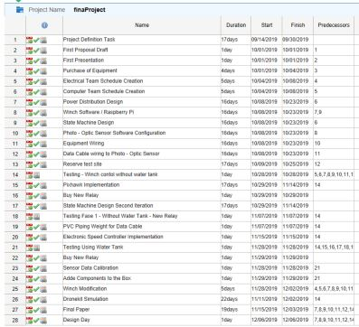

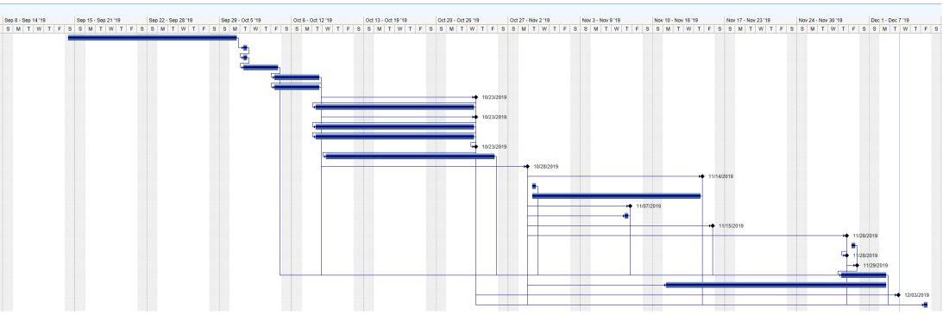

**WINCH CONTROL DEPTH FUNCTION**

|  |
| --- |
| # Function in charge of the Depth  # Will ask the user to insert a desired depth  # therefore activating the winch to move up or down in order to   # reach the depth prompted by the user.    def depth_sensor(value=0.0):     flag = True # this flag is being used in order to signal the very first value read by the sensor  first_depth_read = 0.0 # initialize the first_temp_read to float           # We must initialize the sensor before reading it  if not sensor.init():  print ("Sensor could not be initialized")  exit(1)    # We have to read values from sensor to update depth   if not sensor.read():  print ("Sensor read failed!")  exit(1)      #loop_flag = True   while True:  if sensor.read(): # start sensor reading  if flag == True : # flag helps to only store the first sensor read  first_depth_read = sensor.depth()  print("first_read:", first_depth_read*39.3701, "inches")  flag = False # makes that this if statement is only true once  # Print readings  print("Depth: %.3f inches (freshwater)") % (  sensor.depth()*39.3701 )  if sensor.depth()*39.3701 < value: # is depth from the sensor less then the target depth prompted by the user?  move_down() # activates winch to move down   time.sleep(0.2) # time period the winch is activated    if sensor.depth()*39.3701 >= value : # when similar depth is reach, break from the loop. Later depth can be adjusted by using calculations  loop_flag = False  stop()  break  elif sensor.depth()*39.3701 > value: # is depth from the sensor is greater then the target depth prompted by the user?  move_up() # activates winch to move up  time.sleep(0.2) # time period the winch is activated  #stop() # force the winch to stop rotating  if sensor.depth()*39.3701 <= value : # when similar depth is reached, break from the loop. Later depth can be adjusted by using calculations if needed  loop_flag = False  stop()  break  else:  print ("Sensor read failed!") |

**WINCH CONTROL STOP FUNCTION**

|  |
| --- |
| #Set all the GPIO to logical false def stop():     GPIO.setup(35,GPIO.OUT)  GPIO.output(35,GPIO.HIGH)   GPIO.setup(33,GPIO.OUT)  GPIO.output(33,GPIO.HIGH)    GPIO.setup(40,GPIO.OUT)  GPIO.output(40,GPIO.HIGH)   GPIO.setup(37,GPIO.OUT)  GPIO.output(37,GPIO.HIGH)    GPIO.cleanup |

**WINCH CONTROL MOVE UP AND MOVE DOWN FUNCTION**

|  |
| --- |
| # Set up GPIO pins 40 and 37 to LOW # activating the winch to rotate counter clockwise   def move_up():  stop()  GPIO.cleanup  GPIO.setup(40,GPIO.OUT)  GPIO.output(40,GPIO.LOW)   GPIO.setup(37,GPIO.OUT)  GPIO.output(37,GPIO.LOW)  GPIO.cleanup  # Set up GPIO pins 35 and 33 to HIGH # activating the winch to rotate counter clockwise    def move_down():  stop()  GPIO.cleanup  GPIO.setup(35,GPIO.OUT)  GPIO.output(35,GPIO.LOW)   GPIO.setup(33,GPIO.OUT)  GPIO.output(33,GPIO.LOW)  GPIO.cleanup  **ARM AND TAKEOFF FUNCTION**  #-- Define the function for takeoff  def arm_and_takeoff(tgt_altitude):  print("Arming motors")    while not vehicle.is_armable:  time.sleep(1)    vehicle.mode = VehicleMode("GUIDED")  vehicle.armed = True    while not vehicle.armed: time.sleep(1)    print("Takeoff")  vehicle.simple_takeoff(tgt_altitude)    #-- wait to reach the target altitude  while True:  altitude = vehicle.location.global_relative_frame.alt    if altitude >= tgt_altitude -1:  print("Altitude reached")  break    time.sleep(1)  **MOVE DRONE FUNCTION**  #-- define function to move the drone  def move_drone():  try:  #-- show current location  print("Current Latitude: ", vehicle.location.global_relative_frame.lat)  print("Current Longitude: ", vehicle.location.global_relative_frame.lon)  #-- select new location  lat = input("New Latitude: ")  lon = input("New Longtitude: ")  #-- set the default speed  vehicle.airspeed = input("Select Speed: ")  winch_depth = input("Select Winch Depth: ")  #-- go to new location  print ("Going to new location")  wp1 = LocationGlobalRelative(lat, lon, 10)  vehicle.simple_goto(wp1)  moving = True  #-- notify when arrived at new location  while moving:  time.sleep(0.5)  if lat - .000005 < vehicle.location.global_relative_frame.lat < lat + .000005 and \  lon - .000005 < vehicle.location.global_relative_frame.lon < lon + .000005:  print("Arrived")  moving = False  time.sleep(5)  print("Deploying Winch")  depth_sensor()  except KeyboardInterrupt:  stop() |

**GRAPHICAL INTERFACE SOURCE CODE**

|  |
| --- |
| from tkinter import * import os from test import * import winch_new  window = Tk() # create window  window.configure(background='#95f8b2') # set window background color  window.title("Automated Winch") # set window title  window.geometry('350x200') set window size  def clicked_move_up( ):      btn_up.configure(bg="red") #set button to red after clicked  btn_stop.configure(bg='#e2e2e2') #set button to read  btn_down.configure(bg='#e2e2e2') #set button to read  btn_depth.configure(bg='#e2e2e2') #set button to read  move_up() #execute function call    print("Up")   def clicked_move_down():   btn_down.configure(bg="red") #set button to red after clicked   btn_stop.configure(bg='#e2e2e2') #set button to read  btn_up.configure(bg='#e2e2e2') #set button to read  btn_depth.configure(bg='#e2e2e2') #set button to read  move_down() function call  print("Down")   def clicked_stop():    btn_stop.configure(bg="red") #set button to red after clicked  btn_up.configure(bg='#e2e2e2') #set button to read  btn_down.configure(bg='#e2e2e2') #set button to read  btn_depth.configure(bg='#e2e2e2') #set button to read  stop() # function call  print("Stop")  def clicked_depth():    btn_depth.configure(bg="red") #set button to red after clicked  btn_up.configure(bg='#e2e2e2') #set button to gray  btn_down.configure(bg='#e2e2e2') #set button to gray  btn_stop.configure(bg='#e2e2e2') #set button to gray    depth_sensor(txt.get()) #function call with, txt is the value inputted in the text field    print (txt.get())    #buttons that make function call in order to execute desired functionality. It uses Tkinter button widget  btn_up = Button(window, text="UP", width = 10, height=3, command=clicked_move_up, activebackground='red')   btn_up.grid(column=0, row=0)  btn_down = Button(window, text="Down", width = 10, height=3, command=clicked_move_down, activebackground='red')  btn_down.grid(column=1, row=0)  btn_stop = Button(window, text="Stop", width = 10, height=3, command=clicked_stop, activebackground='red')  btn_stop.grid(column=2, row=0)   btn_depth = Button(window, text="Depth", width = 10, height=3, command=clicked_depth, activebackground='red')  btn_depth.grid(column=0, row=1) # grid position  txt = Entry(window,width=10 ) # text field  txt.grid(column=1, row=1) # grid position  window.mainloop() # keeps window open until manually closed  **MAIN DRONEKIT-SITL FUNCTION**  #------ MAIN PROGRAM ----  if __name__ == "__main__":  stop()  arm_and_takeoff(15)  home_lat = vehicle.location.global_relative_frame.lat  home_lon = vehicle.location.global_relative_frame.lon  active = True  winch = False  while active:  option = raw_input("Select an Option:\nMove and Deploy, Manual Winch, or Land: ")  if option == "Move":  if winch == False:  move_drone()  else:  print("Cannot move while winch is deployed")  elif option == "Winch":  print("\nInput desired command: \n")  print("up -> to move up the winch")  print("\n")  print("down -> to move down the winch")  print("\n")  print( "stop -> to force to stop" )  print("\n")  print("exit -> exit winch control")  print("\n")  command = raw_input(">>> ")  while command != 'exit':  try:  control = ['up','down','stop']  if command in control:  func_dict[command]()  else:  print("wrong input")  print("\n")  command = raw_input(">>> ")  if command == 'exit':  stop()  except KeyboardInterrupt:  stop()  command = 'exit'  print("\n")  print("terminated")  elif option == "Land":  if winch == False:  active = False  else:  print("Cannot land while winch is deployed")  else:  print("Invalid Option, Try Again")  #--- Coming back  print("Coming back to land")  vehicle.mode = VehicleMode("RTL")  homing = True  #-- notify when arrived at home location  while homing:  time.sleep(0.5)  if home_lat - .000005 < vehicle.location.global_relative_frame.lat < home_lat + .000005 and \  home_lon - .000005 < vehicle.location.global_relative_frame.lon < home_lon + .000005:  print("Landing")  homing = False  #-- notify when landed  landing = True  while landing:  time.sleep(0.5)  if vehicle.location.global_relative_frame.alt < 1:  print("Landed")  landing = False  time.sleep(5)  #-- Close connection  vehicle.close() |